Creating and maintaining safe space
- Creating safe space is not always about abuse and harm but can be about day-to-day matters which need attention, and which are affecting the welfare of individuals and their feeling of being safe.

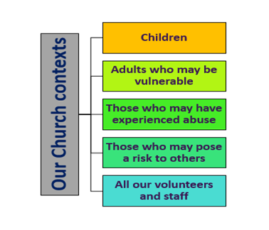 | - You will recall from the Foundation Module that the church is one of the few places in our society where all people can come together.

Healthy culture
- Creating environments in which everyone is safe and can flourish is fundamental to our purpose as God’s Church.

- Although it is not possible to remove all potential for risk or harm, we must all strive to do our best to provide a safe place for everyone by following good practice in every area of church life.

- The image below describes the characteristics of a healthy Christian culture, based on Oakley and Humphreys (2019), who suggest that culture is created by individual behaviour rather than behaviour being influenced by culture.

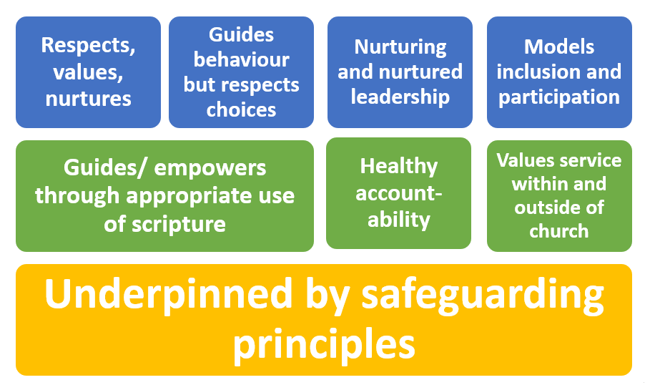

Past Cases Review
- The most influential activity with respect to safeguarding within the Methodist Church in recent years has been the implementation of the learning from the past cases review.

- Since the publication of the report Courage, Cost and Hope in 2015 all the developments in safeguarding training, the Connexional Safeguarding Team, professionalisation of the role of DSOs have been driven by our understanding of the findings, particularly in terms of the 10 themes drafted.

- It is highly recommended that anyone involved in safeguarding in our churches and circuits is aware of these documents, which can be accessed as below:

Courage, Cost and Hope - Past Cases Review

- A summary of the 10 themes can be found on p4

Unacceptable behaviour

- Part of developing and maintaining a healthy culture within our churches is to ensure that they are settings which do not tolerate behaviours such as bullying, racism, sexism or unwanted physical contact.

- For the anti-bullying policy as contained within the Safeguarding policy see p5

- All our relationships with one another must be based upon openness, honesty, trust and respect and therefore it is vital that we set clear boundaries within these relationships as these boundaries serve to protect ourselves and one another.

Examples of unacceptable behaviour include:
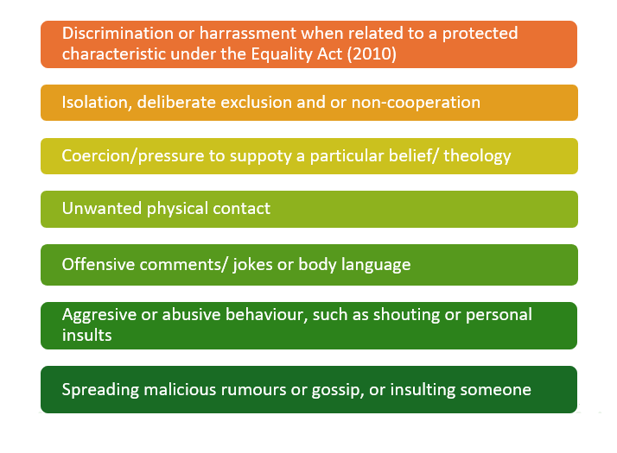 | 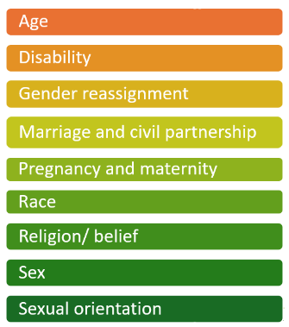

For more information see: Protected characteristics | EHRC (equalityhumanrights.com)

Working with unacceptable behaviour

Where there have been instances when someone has responded to something, or behaved in a manner, that others have found threatening or inappropriate it can be useful to work with them supportively before the situation reaches that of formal complaint or referral as bullying/ harassment.

The model below offers such a framework.

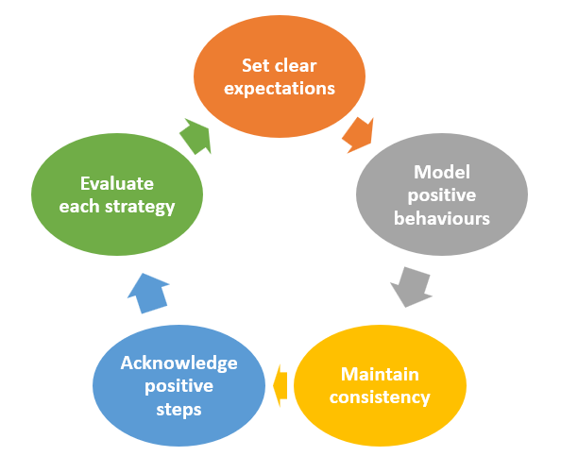

Themes from the Past Cases Review
1 | Abuse and risk are still not always recognised | consider | worrying behaviour  patterns of behaviour  grooming
2 | The huge and ongoing impact of abuse on those who have been harmed | consider | emotionally  physically  psychologically spiritually
3 | Abuse which has occurred in the church setting is even more distressing and is a devastating breach of trust
4 | There is a need for the further development of listening skills | with belief  with attention  with more than our ears
5 | People in the church are still not responding well to serious situations | consider | naïve  poor sharing of information, try to handle internally
6 | People find it difficult to put respectful uncertainty into practice | aka healthy scepticism  avoid false optimism
7 | Responding well to the church congregation in difficult safeguarding situations continues to be a challenge
8 | Recording: Practice has improved but record keeping is still not consistent enough
9 | Effective working with other agencies still requires development | consider | police  social care health  voluntary sector
10 | There is insufficient understanding of the significance of safeguarding concerns about those who hold leadership roles

Anti-Bullying Policy
Taken from Appendix 1 - Safeguarding Policy, Procedures and Guidance for the Methodist Church in Britain (July 2023)
Bullying, Harassment And Safeguarding

The Methodist Church offers a warm welcome to everyone and strives to be a safer place for all where all forms of bullying and harassment will not be tolerated.

Policy Statement

Bullying and harassment are unacceptable and never excusable. The Methodist Church holds that all forms of bullying and harassment are unacceptable, inconsistent and incompatible with the Christian faith and a Christian way of living. The Methodist Church is committed to being a safer space for all. This means ensuring that members of the Methodist Church have an understanding and awareness of harassment and bullying and know how to respond appropriately, and that there are processes in place to enable the issues to be addressed. Victims of bullying or harassment can expect to be listened to, taken seriously and supported when they disclose that they are subject to bullying or harassment. Local Churches can receive advice and support from their Church/Circuit Safeguarding Officer and the District Safeguarding Officer.

Definition of Bullying and Harassment

There is no single definition of bullying. The Advisory, Conciliation and Arbitration Service (ACAS) state that bullying may be characterised as offensive, intimidating, malicious or insulting behaviour, an abuse or misuse of power through means that undermine, humiliate, denigrate or injure the recipient. Bullying or harassment may be carried out by an individual against an individual (perhaps by someone in a position of authority) or involve groups of people. It may be obvious, or it may be insidious. Whatever form it takes, it is unwarranted and unwelcome to the individual.

The Methodist Church offers this definition as follows:

Any behaviour, always involving a misuse of power, which an individual or group knows, or ought reasonably to know, could have the potential effect of offending, humiliating, intimidating or isolating an individual or group should be regarded as unacceptable.

‘Unacceptable behaviour’ changes its label to ‘bullying’ or ‘harassing behaviour’ when it causes actual harm or distress to the target(s), normally, but not exclusively, after a series of incidents over a prolonged period of time.

Lack of intent does not diminish, excuse or negate the impact on the target or the distress caused. The degree of intent is only relevant in terms of how the behaviour should be challenged and the issues subsequently resolved. (Positive Working Together - A Short Guide 2015)

Harassment refers to poor treatment related to a protected characteristic (ACAS 2020):

age | sex | disability
gender reassignment | marriage and civil partnership | pregnancy and maternity
race | religion or belief | sexual orientation

While bullying itself is not against the law, harassment is. It is against the law to discriminate against someone on any of the above grounds under the Equality Act (2010). You are also protected from discrimination if:
- you are associated with someone who has a protected characteristic, for example a family member or friend
- you have complained about discrimination or supported someone else’s claim

Bullying and harassment is behaviour that makes someone feel intimidated or offended -

Workplace bullying and harassment - GOV.UK (www.gov.uk).

These terms are often used interchangeably and some definitions include bullying as a form of harassment.

Safeguarding
Safeguarding is the action the Methodist Church takes to promote a safer culture. This means we will:
- promote the welfare of children, young people and adults

- work to prevent abuse from occurring

- seek to protect and respond well to those that have been abused

The aim of the Methodist Church’s Safeguarding Policy, Procedures and Guidance is to ‘create Christian communities of love and care, where good practice to promote the welfare of children, young people and adults becomes a way of life.’

Types of Bullying
There are different types of bullying and some can be covert and therefore more difficult to spot, but others more obvious and therefore easier to identify. It is helpful to split these in to different categories:

Physical Bullying | This can include hitting, kicking, tripping, pinching, pushing or damaging property.
Verbal Bullying | This can include name-calling, insults, snide remarks, teasing, intimidation, homophobic or racist remarks, or verbal abuse.
Social Bullying | May include:  - Lying and spreading rumours  - Negative facial or physical gestures, menacing or contemptuous looks  - Playing nasty jokes to embarrass and humiliate  - Mimicking unkindly  - Encouraging others to social exclude someone  - Damaging someone’s social reputation or social acceptance.
Cyber Bullying | This can happen at any time and be in public or in private and consist of the following:  - abusive or hurtful texts, emails or posts, images or videos  - deliberately excluding others online  - nasty gossip or rumours  - imitating others online or using their log-in.
Bullying and harassment can happen: | - face-to-face  - via a third party instigating by the ‘primary’ bully  - by letter  - by email  - via any digital platform  - by phone (mobile or landline).

What is not bullying:
- single episodes of social rejection or dislike
- single episode acts of nastiness or spite
- random acts of aggression or intimidation
- mutual arguments, disagreements or fights.

These actions can cause great distress, but do not fit the definition of bullying unless someone is deliberately and repeatedly doing them (National Centre for Bullying 2020). The Methodist Church does have systems in place to deal with those within the church who are perpetrators of bullying or harassment. The Complaints and Discipline process is one route, but this does not apply to those who are not members of the Methodist Church. To help ensure any allegations of bullying or harassment are dealt with in a timely, sensitive and comprehensive manner and that pastoral care for the victim is prioritized the procedures for any allegation or complaint are detailed in the flow chart (see appendix).

Support Organisations

National bullying helpline | Information and advice about all forms of bullying for children and adults | nationalbullyinghelpline.co.uk
Family Lives | Advice for parents and carers | Family Lives

Bullying and harassment flow chart

