Equality, Diversity, Inclusion
Conference 2021 adopted the paper Strategy for Justice, Dignity and Solidarity. This is the churches Equality, Diversity and Inclusion (EDI) work.

This means we aim:

- to celebrate the rich diversity of people within the Methodist Church

- to eradicate all discrimination, to treat all people justly and with dignity across the breadth of the Methodist Church

- for a profound change in the culture, practices and attitudes of the Methodist Church so that all Methodists are able to be full participants in the Church’s life.

Therefore, although not directly a safeguarding issue, it sits alongside very comfortably, sharing many similar principles.

Justice, Dignity and Solidarity

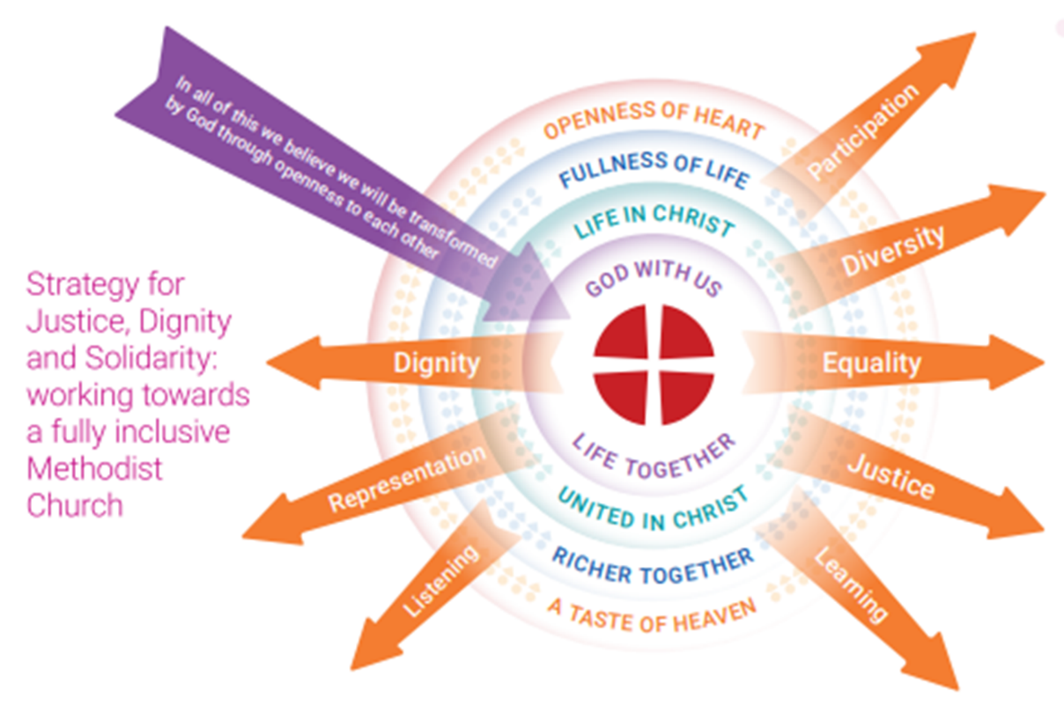

- Fundamental to our belief as Methodists is that all human beings are loved by and created in the image of God, and our calling has always included a call to social justice. And yet we have often failed to live that out because we have excluded people based on prejudice, whether consciously or unconsciously.

- The report demands that the church reviews the entire way it works, accepting that in the past our systems and power dynamics have left many people excluded.

- Therefore, we are being challenged again, as we have been through the Past Cases Review in terms of safeguarding, to reflect on the need for cultural and attitudinal change to avoid the repeating the same mistakes by saying this is the way things are done around here and we must all be open to a change of heart mind and action.

Unconscious bias and its relationship with safeguarding
- We know that safeguarding children and adults who may be vulnerable is everyone’s responsibility.

- However, in culturally diverse Britain, we can find ourselves presented with situations where issues of culture and safeguarding collide.
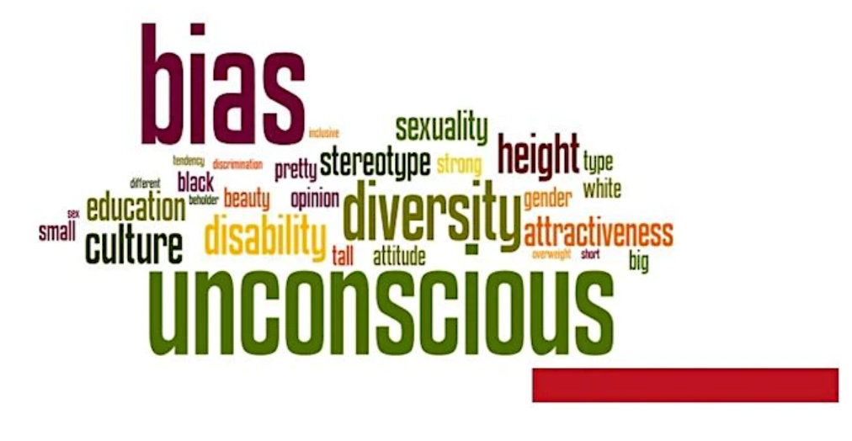

- Although it is important to be sensitive to the culture of an individual, we need to recognise that we must effectively safeguard all who are vulnerable or who may be at risk.

- This can be a difficult balance and a challenge for us all when the abuse is justified or condoned based on traditional family practices or cultural expectations.

- However, we must also be alert to the potential of our own unconditional biases.

- These may relate to practices which we may perceive as harmful, based on our own experience or to unconscious racial prejudice.

- We would therefore refer you to consider this further and to engage with the relevant Methodist training.

Further Useful Guidance

Information about accessing EDI and unconscious bias training for those for whom it is mandatory. | Mandatory EDI Training (Equality, Diversity and Inclusion) (methodist.org.uk)
The toolkit seeks to equip Methodists to go beyond legal compliance and there are seven main modules.  Module 1.2, the Theological Underpinning, is crucial to understanding the Toolkit as a whole. |  | EDI toolkit modules (methodist.org.uk)
PDF of Module 1.4 Unconscious Bias,  Equality Diversity and Inclusion Toolkit | module-14-unconscious-bias.pdf (methodist.org.uk) module-14-uncons
Introduction to Unconscious Bias – for church councils, circuit meetings, circuit invitation committees and other groups | Introduction to Unconscious Bias

