Local Guidance for those with Safeguarding Responsibility
Introduction
The Constitutional Practice and Discipline of the Methodist Church sets out how Church Councils, Circuit Meetings and District Synods hold ultimate responsibility for safeguarding of all volunteers and employees in their particular settings. This guidance therefore seeks to be a resource to promote best practice for all those in roles with a significant safeguarding element across the Manchester & Stockport and Bolton & Rochdale Methodist Districts. It is particularly relevant for superintendents, ministers and Church and Circuit Safeguarding Officers (SGOs) in order to enable them to support all volunteers and lay staff.

This guidance recognises that a healthy Christian community is one in which people know that they are loved, visitors are welcome and young and old alike are valued and feel safe. The care that we offer, both at times of crisis and in everyday life, is an active declaration of God's love in Christ and for all the world.

Safeguarding is central to the mission of the church and its ministry. God’s love for the vulnerable and our calling to share the good news of the risen Christ to all people shape everything we do, including our ever-increasing focus on safeguarding. In Psalm 82, the psalmist instructs the people of Israel:

“Defend the weak and the fatherless; uphold the cause of the poor and the oppressed. Rescue the weak and the needy; deliver them from the hand of the wicked.”

Too often people see safeguarding as something merely required of us by law and the Connexion, possibly even an annoyance or a risk to other aspects of our work. However, Jesus demonstrated his love and care for those who were broken, wounded and abused as well as those pushed out of society, denied a voice, and taught that we should love, embrace and share our Christian life with those who may be vulnerable or marginalised. This is, and always has been, our calling.

Our understanding and commitment to safeguarding within the Church and the Church’s outreach work continues to grow and develop as we encourage a healthy safeguarding culture, we recognise that our Church is only as strong and effective as the people who dedicate their time, energy and enthusiasm to work with and serve others, either within ministry, lay or volunteer roles. However, we also recognise that:

“Human beings can do terrible things to each other and the Church has never been immune from that fact. We recognise that we are sinners and that in sinfulness we can damage one another horribly.” The Revd Dr Jonathan Hustler, the Secretary of the Conference January 2020
Key Principles for an effective safeguarding culture within the Church
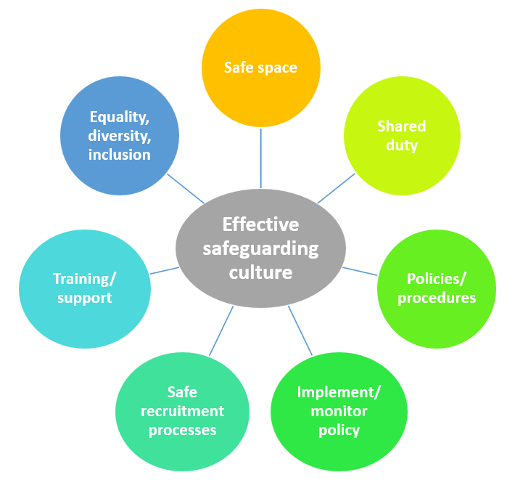

Many of these principles overlap with one another or with other aspects of church life, such as health and safety, first aid, property or the Justice, Dignity and Solidarity Strategy of the Methodist Church.
Although not directly the responsibility of those with specific safeguarding responsibility there is a need to liaise and work with such other role holders within our churches and circuits to ensure that we can create and then maintain safe spaces where all can meet in love and mutual understanding to work together to grow the Kingdom of God on earth.
More details and reference to other guidance can be found in the other sections of the website.

CPD (methodist.org.uk)

