Local and National contacts
On the following pages you will find contact details for:

- adult social care services, children’s social care services, Local Authority Designated Officers (LADO) and domestic abuse services across a number of local authorities

- GM and wider support services

- National support services

Page | Local Authority
5 | Blackburn with Darwen
6 | Blackpool
7 | Bolton
9 | Bury
11 | Cheshire East
13 | Cheshire West and Chester
15 | Derby & Derbyshire
17 | Lancashire
19 | Manchester
21 | Oldham
23 | Rochdale
25 | Salford
27 | St Helens
28 | Stockport
29 | Tameside
30 | Trafford
31 | Warrington
33 | Wigan

Page

35  36 | Domestic abuse services  Sexual abuse services | End the Fear  Merseyside domestic violence service  q  St Mary’s  Safe Place Merseyside  Survivors Manchester (male victims)
 | Children and young people | GM victims’ services (with links to a range of issues)
37 | Services Directory Search (across all of GM, for specific or general services)
Local support services

National support services

Page

38 | Children and young people | Action for Children  Afruca  ARC (for those with autism and learning difficulties)  Barnados
39 |  | Child Exploitation and Online Protection  Challenging behaviour foundation  Childline  Lucy Faithfull Foundation
40 | Vulnerable adults | NSPCC  Parents Protect!  Stop It Now  Hourglass  Age UK
41 | Domestic abuse and violence | Domestic Violence Assist  Female Genital Mutilation Helpline Forced marriage  Galop (support for LGBT+)
42 |  | Karma Nirvana  Mankind initiative  Muslim Women’s Network  National Domestic Abuse Helpline (Refuge)  National Stalking Helpline  Rape Crisis
43 | Survivors of abuse | Respect  Restored  Women’s Aid  MACSAS (Minister and Clergy Sexual Abuse Survivors)  NAPAC (National Association of People Abused in Childhood)
44 | Mental Health | One in Four  SurvivorsUK  Better Health: every mind matters  CALM (the Campaign Against Living Miserably)  Mental Health Foundation
45 |  | Mind  Papyrus  Place2Be  Shout  YoungMinds
46 | Other support and advice | Alcoholics Anonymous  Drinkaware  Frank: Drug and Alcohol Helpline  Gamble aware  Mencap  Prison Advice and Care Trust
47 |  | Respond  Samaritans  Sibs  Stop! Think Fraud  The Traveller Movement  Unlock (those leaving prison)
48 |  | Unseen (survivors of trafficking and modern slavery)  Vesta (Polish families)  Women in Prison

Blackburn with Darwen

Adult social care

 | Office hours - 01254 585 949  Out of hours - 01254 587 547
Referral | Report a safeguarding concern | Blackburn with Darwen Borough Council
Website | Get in touch | Blackburn with Darwen Borough Council  Safeguarding adults | Blackburn with Darwen Borough Council

Children’s advice and duty service (CADS)
Office hours - 01254 666 400

Out of hours - 0300 123 5022

Website | Children’s advice and duty service (CADS) | Blackburn with Darwen Borough Council
  Other info | Blackburn with Darwen Council Local Safeguarding Children Board (lscb.org.uk)

Local Authority Designated Officer (LADO)
Website | Local Authority Designated Officer (LADO) | Blackburn with Darwen Borough Council

Domestic abuse – The Wish Centre
 | 0300 561 0440
Website | Domestic abuse | Blackburn with Darwen Borough Council  About | The Wish Centre

Blackpool

Adult social care

Office hours - 01253 477592
Out of hours - 01253 477600
Referral | Referral form (blackpool.gov.uk)
 Email | adult.socialcare@blackpool.gov.uk

Children’s Multi Agency Safeguarding Hub
 | 01253 477299 – 24 hours
Website | Blackpool Council | Worried about a child | Child abuse reporting
Other info | Children's social care (blackpool.gov.uk)  Children's Safeguarding Assurance Partnership

Local Authority Designated Officer (LADO)
Website | Office hours - 01253 477299  Out of hours - 01253 477600

Domestic abuse Fylde Coast Women’s Aid
Helpline – 01253 596699

Office - 01253 752014

Website | Fylde Coast Women’s Aid - Fylde Coast Women's Aid - FCWA
Other info | Domestic abuse (blackpool.gov.uk)  Sanctuary service referral form (blackpool.gov.uk) – for any person threatened with homelessness due to domestic abuse

Bolton

Adult Social Care

Office hours - 01204 337000

Out of hours - 0300 123 5022

Referral | Adult Social Care: Adult safeguarding referral
Website | Safeguarding and protecting adults – Bolton Council
Other info | Adult social care – Bolton Council  Assessing your social care need – Bolton Council

Children’s Social Care
Office hours - 01204 331500

Out of hours - 01204 337777

Referral | Schools and children: Child referral
Website | Worried about a child? – Bolton Council
Other info | Home – Bolton Safeguarding Children

Local Authority Designated Officer (LADO)
 | 01204 337474
Referral | LADO_Referral_Form.docx (live.com)

Domestic abuse
Fortalice Endeavour Project/Paws for Kids
 | 01204 365677 | 01204 394842
Website | Fortalice - Domestic Abuse | Endeavour (endeavourproject.org.uk)
Other info | Domestic abuse and violence – Bolton Council

Bury

Adult Social Care

Office hours - 0161 253 5151

Out of hours - 0161 253 6606

Referral | Report an adult safeguarding concern - Bury Council
Website | Adult Social Care - Bury Council
Other info | Safeguarding adults - Bury Safeguarding Partnership

Children’s Multi Agency Safeguarding Hub
Office hours - 0161 253 5678

Out of hours - 0161 253 6606

Referral | Report a child at risk - Bury Council
Website | Child Care and Support - Bury Council
Other info | Safeguarding children - Bury Safeguarding Partnership

Local Authority Designated Officer (LADO)
Website | 0161 253 5342
Email | lado@bury.gov.uk

Domestic abuse – Safenet
 | 0300 3033 581
Website | Bury Services - Safenet
Other info | Domestic violence and abuse - Bury Council

Cheshire East
Adult Social Care
 | South team: Congleton, Holmes Chapel, Sandbach, Middlewich, Alsager, Scholar Green, Haslington, Nantwich, Audlem, Crewe, Wrenbury, Bunbury, Malpas, Acton, Wybunbury, Shavington, Cholmondeley, Minshull Vernon, Bridgemere, Church Lawton, Mow Cop | East team: Alderley Edge, Wilmslow, Handforth, Chelford, Knutsford, Poynton, Bollington, Disley and Macclesfield
Office hours - 0300 123 5010

Out of hours - 0300 123 5022

Referral | Safeguarding Adults at risk (cheshireeast.gov.uk)
Website | Keeping adults safe (cheshireeast.gov.uk)
Other info | Care and support for adults (cheshireeast.gov.uk)

Children’s Multi Agency Safeguarding Hub
 | Office hours - 0300 123 5012 (option 3, option 2)  Out of hours - 0300 123 5022 | 07784 492174  07814 369297  07966 305353
Email | CHECS@cheshireeast.gov.uk
Referral | Child Protection Concerns (cheshireeast.gov.uk)
Website | Safeguarding & Child Protection (cheshireeast.gov.uk)
Other info | Cheshire East Safeguarding Children's Partnership (CESCP)

Local Authority Designated Officer (LADO)
Website | 01270 685904
Referral | LADO Consultation (cheshireeast.gov.uk)
Email | LADO@cheshireeast.gov.uk

Domestic abuse – Cheshire East Domestic Abuse Hub
 | 0300 123 5101
Email | cedah@cheshireeast.gov.uk
Referral | cedah@cheshireeast.gov.uk
Website | Cheshire East Domestic Abuse and Sexual Violence Partnership  Domestic abuse tools and resources (cheshireeast.gov.uk)

Cheshire West and Chester

Adult social care – Community Access Team

Office hours: 0300 1237034
Out of hours: 01244 977277

Referral | Safeguarding Concerns form (cheshirewestandchester.gov.uk)
Website | Adult social care | Cheshire West and Chester Council  Adults at risk | Cheshire West and Chester Council
Other info | Local Safeguarding Adults Board (LSAB) | Cheshire West and Chester Council

Children’s Integrated Access and Referral Team (iART)
Office hours: 0300 123 7047

Out of hours: 01244 977277

Email | i-ART@cheshirewestandchester.gov.uk
Referral | Report a concern about a child. - Your data - Self (achieveservice.com)
Website | Children and young people | Cheshire West and Chester Council
Other info | Cheshire West Safeguarding Children Partnership (cheshirewestscp.co.uk)

Local Authority Designated Officer (LADO)
Referral | allegations-lado-referral-form.doc (live.com)
Email | safeguardinglado@cheshirewestandchester.gov.uk
Website | Allegations Management (LADO)

Domestic abuse
 | 0300 123 7047 option 2
Website | Domestic abuse | Cheshire West and Chester Council  Home - Open the Door Cheshire

Derby and Derbyshire

Adult social care

 | Derbyshire  Office hours - 01629 533190  Out of hours - 01629 532600 | Derby City  Office hours- 01332 642855  Out of hours - 01332 786968
Referral | safeguarding-adults-referral-form.docx (live.com)
Other info | Safeguarding adult referrals - Derbyshire SAB

Childrens Social Care
 | Derbyshire  Office hours - 01629 533190  Out of hours - 01629 532600 | Derby City  Office hours- 01332 641172  Out of hours - 01332 956606
Website | Derbyshire –  Starting Point contact and referral service - Derbyshire County Council | Derby –  Safeguarding children - Derby City Council
Other info | BDerby Safeguarding Children Partnership (ddscp.org.uk)

Local Authority Designated Officer (LADO)
Email | Derbyshire  professional.allegations@derbyshire.gov.uk. | Derby City  CPMduty@derby.gov.uk
Referral | Allegations (ddscp.org.uk)  Derby and Derbyshire LADO form FINAL April 2023 V2.docx (live.com)
Website | Local Authority Designated Officer (LADO) | Blackburn with Darwen Borough Council

Domestic abuse – The Elm Foundation
 | 08000 198 668
Email | derbyshiredahelpline@theelmfoundation.org.uk
Website | Freedom From Domestic Abuse | Everyone Deserves To Feel Safe (theelmfoundation.org.uk)  Domestic abuse (saferderbyshire.gov.uk)  Domestic abuse advice - Derby City Council

Lancashire

Adult Social Care

Office hours - 0300 123 6720
Out of hours - 0300 123 6722
Referral | Are you concerned about a vulnerable adult? - Lancashire County Council
Website | Adult social care - Lancashire County Council
Other info | Lancashire Safeguarding Adults Board - Lancashire Safeguarding Children Board

Children’s Services Support Hub and Multi Agency Safeguarding Hub (MASH)
Office hours - 0300 123 6720
Out of hours - 0300 123 6722
Website | Safeguarding children - Lancashire County Council
Other info | Children's Safeguarding Assurance Partnership

Local Authority Designated Officer (LADO)
 | 01772 536 694
Email | LADO.Admin@lancashire.gov.uk

Domestic abuse
 | Lancashire Safe at Home - 0300 3033 581
Email | Lancashirerefuges@safenet.org.uk
Website | Domestic abuse - Lancashire County Council
Other info | Lancashire Safe At Home - Safenet  Lancashire Refuges - Safenet  Domestic abuse - Nest Lancashire

Manchester

Adult Social Care

 | 0161 234 5001
Referral | Report a Social Care for Adults Online Referral | Who is the referral for? (manchester.gov.uk)
Website | Get help, support or social care | Get help, support or social care | Manchester City Council
Other info | Adult Safeguarding - Manchester Safeguarding Partnership

Children’s Multi Agency Safeguarding Hub

 | 0161 234 5001
Email | mcsreply@manchester.gov.uk
Referral | Tell us about someone being abused or neglected | Tell us about someone being abused or neglected | Manchester City Council
Website | Children's services | Manchester City Council
Other info | Children's Safeguarding - Manchester Safeguarding Partnership

Local Authority Designated Officer (LADO)

 | 0161 234 1214
Email | qualityassurance@manchester.gov.uk

Domestic abuse The Pankhurst Trust
 | 0161 660 7999
Email | referrals@manchesterwomensaid.org
Referral | Referrals form | The Pankhurst Trust and Manchester Women's Aid
Website | The Pankhurst Trust (Incorporating Manchester Women's Aid) | The Pankhurst Trust and Manchester Women's Aid
Other info | Get help and advice about domestic abuse | Get help and advice about domestic abuse | Manchester City Council

Other services
Saheli | Supports Black Asian Ethnic Minority women and children fleeting domestic abuse, honour-based violence and forced marriage
 | 0161 945 4187
Email | help@saheli.org.uk
Website | Saheli

Oldham

Adult Social Care

Office hours – 0161 770 7777
Out of hours - 0161 770 6936

Email | adult.mash@oldham.gov.uk
Referral | Request support from Adult Social Care - Oldham Council
Website | Request support from Adult Social Care
Other info | OSAB | Welcome

Children’s Multi Agency Safeguarding Hub
Office hours – 0161 770 7777
Out of hours - 0161 770 6936
Referral | child.mash@oldham.gov.uk  MASH Referrals (oldham.gov.uk)
Website | Protecting children | Oldham Council
Other info | OSCP | Welcome (olscb.org)

Local Authority Designated Officer (LADO)
 | 0161 770 8870 Mobile: 07583 101 863
Email | colette.morris@oldham.gov.uk
Referral | TEMPLATE-LADO-Referral-Form.docx (live.com)
Website | LADO | Oldham Safeguarding Children Partnership (olscb.org)

Domestic abuse – Safenet

 | 0300 3033 581
Email | contact@safenet.org.uk
Website | Oldham - Safenet  Organisations that offer support Oldham Council

Rochdale

Adult Social Care

Office hours - 0300 303 8886

Out of hours - 0300 303 8875

Referral | adult.care@rochdale.gov.uk
Website | About safeguarding adults at risk

Children’s Multi Agency Safeguarding Hub
 | 0300 303 0440
Email | ehash@rochdale.gov.uk
Website | Report a child at risk | Rochdale Borough Council
Other info | Rochdale Safeguarding Partnership Board - Bullying

Local Authority Designated Officer (LADO)
Email | lado@rochdale.gov.uk
Referral | lado_referral_form.docx (live.com)
Website | Rochdale Safeguarding Partnership Board - Allegations Management

Domestic abuse Safenet
 | 0300 3033 581
Email | contact@safenet.org.uk
Website | Rochdale Services - Safenet
Other info | Domestic violence and abuse – Rochdale Borough Council  Our Rochdale | Domestic Violence and Abuse - Where to find help

Salford

Adult Social Care

Office hours - 0161 206 0604

Out of hours - 0161 794 8888

  Email | salford.socialservices@nca.nhs.uk
Referral | Report a Safeguarding Concern (salford.gov.uk)
Website | Adult social care•Salford City Council
  Other info | Salford Safeguarding Adults Board

The Bridge Partnership Children’s Hub
 | Office hours - 0161 603 4500  Out of hours - 0161 794 8888
Email | worriedaboutachild@salford.gov.uk
Referral | Salford Children and Families Portal
Website | Worried about a child•Salford City Council
Other info | Home | Salford Safeguarding Children Partnership

Local Authority Designated Officer (LADO)
 | 0161 603 4350
Email | LADO@salford.gov.uk
  Referral | salford-lado-referral-form-may-2020.docx (live.com)
Website | Managing allegations against adults who work with children | Salford Safeguarding Children Partnership

Domestic abuse
Greater Manchester Domestic Abuse Helpline - 0800 254 0909

Safe in Salford - 0161 793 3232

Email | info@safeinsalford.org.uk.
Website | Safe in Salford – Salford Foundation
Other info | Salford Women's Aid | Domestic Abuse Charity (salfordwomensaid.org)

St Helens

Adult Social Care

 | 01744 676767
Website | About Adult Social Care (sthelens.gov.uk)
Other info | Safeguarding Adults Board - St Helens Borough Council

Children’s Multi Agency Safeguarding Hub
Office hours - 01744 676767

Out of hours - 0345 050 0148

Website | Children's services - St Helens Borough Council
Other info | St. Helens Safeguarding Children Partnership - scp (sthelenssafeguarding.org.uk)

Local Authority Designated Officer (LADO)
 | 01744 671252
Email | sthelenslado@sthelens.gov.uk
Referral | st_helens_lado_referral.doc (live.com)
Website | St. Helens Safeguarding Children Partnership - Families (sthelenssafeguarding.org.uk)

Domestic abuse Safe2Speak

Domestic Abuse Services Open 8am - 5pm 01744 743200

24hr free Helpline - 01925 220541

Website | Safe2Speak | Support from the St Helens Domestic Abuse Team

Stockport

Adult Social Care

Office hours - 0161 217 6029
Out of hours - 0161 718 2118

Website | Safeguarding adults - Stockport Council  Report suspected abuse or neglect - Stockport Council
Other info | Safeguarding Adults in Stockport

Children’s Multi Agency Safeguarding Hub
Office hours - 0161 217 6028

Out of hours - 0161 718 2118

Website | Contacting the MASSH - Stockport Council
Other info | Safeguarding Children in Stockport |

Local Authority Designated Officer (LADO)
Coordinator 0161 217 6029

LADO (for advice) 0161 474 5657

Referral | Professional allegation reporting form (stockport.gov.uk)
Website | Contacting the LADO (Local Authority Designated Officer) - Stockport Council

Domestic abuse Stockport Without Abuse
 | 0161 477 4294
Email | info@stockportwithoutabuse.org.uk
Website | Stockport Without Abuse
Tameside
Adult Social Care

 | 0161 922 4888
Email | ProtectAdults@tameside.gov.uk
Website | Adult Abuse – Protecting Vulnerable Adults (tameside.gov.uk)
Other info | Tameside Adults Safeguarding Partnership Board

Children’s Safeguarding – Public Service Hub
Office hours – 0161 342 4101

Out of hours – 0161 342 2222

Website | Children’s Social Care (tameside.gov.uk)l
Other info | Tameside Safeguarding Children Partnership

Local Authority Designated Officer (LADO)
Email | 0161 922 4888
Referral | Tameside-LADO-referral-form.docx (live.com)
Website | Management of Allegations (tameside.gov.uk)

Domestic abuse Bridges
 | 0800 328 0967 / 0161 331 2552
Email | bridges@jigsawhomes.org.uk
Website | Bridges domestic abuse service in Greater Manchester – Jigsaw Support (jigsawhomes.org.uk)
Trafford
Adult Social Care

 | 0161 912 5135
Email | AdultSafeguardinghub@trafford.gov.uk
Referral | publicconcern (trafford.gov.uk)
Website | Safeguarding Adults (traffordsafeguardingpartnership.org.uk)

Children’s Multi Agency Safeguarding Hub
Office hours - 0161 912 5125
Out of hours - 0161 912 2020

Website | Trafford Children's First Response
Other info | Trafford Strategic Safeguarding Board (traffordsafeguardingpartnership.org.uk)

Local Authority Designated Officer (LADO)
Referral | Allegation of professional abuse (egovhub.net)
Website | Allegations against adults who work with children (traffordsafeguardingpartnership.org.uk)

Domestic abuse Trafford Domestic Abuse Services
 | 0161 872 7368
Website | Home | tdas | Trafford Domestic Abuse Services | Stretford, Manchester

Warrington

Adult Social Care

Office hours - 01925 443322
Out of hours - 01925 444400

Referral | Adult Safeguarding Referral - My Warrington
Website | Adult social care | warrington.gov.uk
Other info | Warrington Safeguarding Partnerships - Welcome to Warrington’s Safeguarding Adult Board (WSAB)

Children’s Multi Agency Safeguarding Hub
Office hours - 01925 443322 option 1

Out of hours - 01925 443322 option 2

Referral | Children and Families Request for Support - My Warrington
Website | Report abuse of children and young people | warrington.gov.uk
Other info | Warrington Safeguarding Partnerships - Welcome to the Safeguarding Children Partnership

Local Authority Designated Officer (LADO)
 | 01925 442079
Email | lado@warrington.gov.uk
Website | Local authority designated officer (LADO) | warrington.gov.uk

Domestic abuse

Warrington Domestic Abuse hub - 01925 243359

Warrington Women's Aid Refuge - 01925 417138

Website | Domestic abuse support | warrington.gov.uk

Other Services
Listening Ear - DiAmond (domestic abuse emotional support) counselling and Therapeutic Support Service for Children and Young people affected by Domestic Abuse

 | 0151 488 6648
Email | enquiries@listening-ear.co.uk
Website | Warrington Merseyside - Listening Ear
RASASC - Rape and sexual abuse support centre for adults, children and young people in Cheshire and Merseyside

 | 0330 363 0063
Email | support@rapecentre.org.uk
Website | RapeCentre UK

Wigan

Adult Social Care

Referral | Report concerns of abuse or neglect of a vulnerable adult (wigan.gov.uk)
Website | Adult Social Care and Health (wigan.gov.uk)
Other info | Wigan Safeguarding Adults Board

Children’s Multi Agency Safeguarding Hub
 | 01942 828300 (24 hours)
Website | Children's health and social care (wigan.gov.uk)
Other info | Wigan Safeguarding Childrens Board - Homepage (wiganlscb.com)

Local Authority Designated Officer (LADO)
Office hours - 01942 486042

Out of hours - 01942 828300

Email | lado@wigan.gov.uk
Referral | LADO notification form (wigan.gov.uk)
Website | Local Authority Designated Officer (LADO) (wiganlscb.com)

Domestic abuse DIAS WHAG
 | 01706 298 222 | 01706 298 222
Email | admin@diasdvc.org | WiganDAS@whag.info.
Website | DIAS Domestic Abuse Centre | Wigan Borough Domestic Abuse Service (diasdvc.org) | Wigan domestic abuse service - WHAG
Other info | Domestic abuse (wigan.gov.uk)

GM and wider support services
Domestic abuse
  End The Fear - Help Someone You Know | Greater Manchester against Domestic Abuse provide help, support and advice to anybody who is experiencing domestic or sexual violence within Greater Manchester or knows anyone who is.  Greater Manchester Domestic Abuse Helpline: 0161 636 7525

  Merseyside Domestic Violence Service | Merseyside Domestic Violence Service, formally known as Chrysalis, provide services for women and girls, children and young people, families and men, including support and help for domestic abuse, stalking and cultural or honour-based crime.  Tel: 07802 722703

Sexual Assault
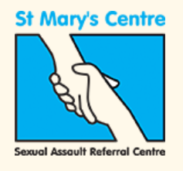  St Mary's Centre | Saint Mary’s Sexual Assault Referral Centre (SARC) offer services to aid recovery from both the physical and emotional effects of rape and sexual assault.  24-hour helpline: 0161 276 6515

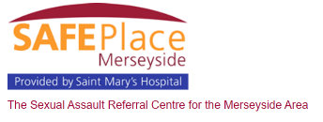  SAFE Place Merseyside | SAFE Place Merseyside is the Sexual Assault Referral Centre for the Merseyside area  Tel: 0151 295 3550

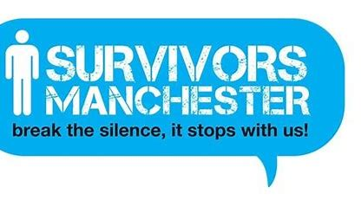  Survivors Manchester - Break the silence | Survivors Manchester UK - helping male victims of sexual assault and abuse to break the silence.  Tel: 0808 800 5005

Children and Young People

Children & Young People | Greater Manchester Victims' Services (gmvictims.org.uk)

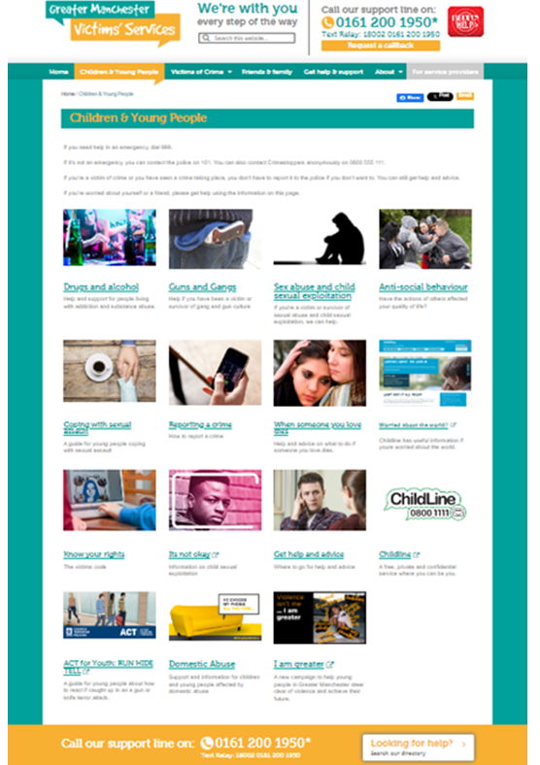 | With links to services for:  Drugs and alcohol  Guns and Gangs  Sex abuse and child sexual exploitation  Anti-social behaviour  Coping with sexual assault  Reporting a crime  When someone you love dies  Worried about the world?  Know your rights  It’s not okay  Get help and advice  Childline  Domestic Abuse  I am greater
Services Directory Search
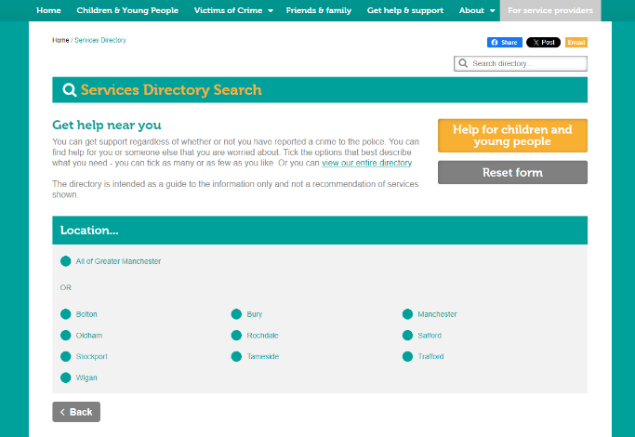  General help: search across all of Greater Manchester or within specific boroughs. | Search Services | Greater Manchester Victims' Services (gmvictims.org.uk)

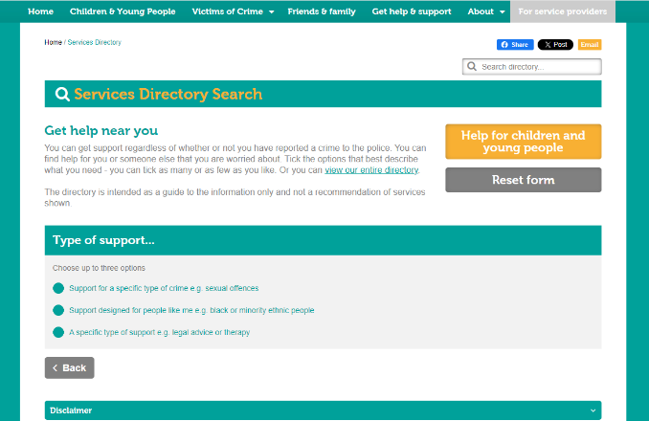  Support for a specific type of crime e.g. sexual offences  Support designed for people like me e.g. black or minority ethnic people  A specific type of support e.g. legal advice or therapy | Search Services | Greater Manchester Victims' Services (gmvictims.org.uk)

National Support Services

Organisations offering support and advice – Children

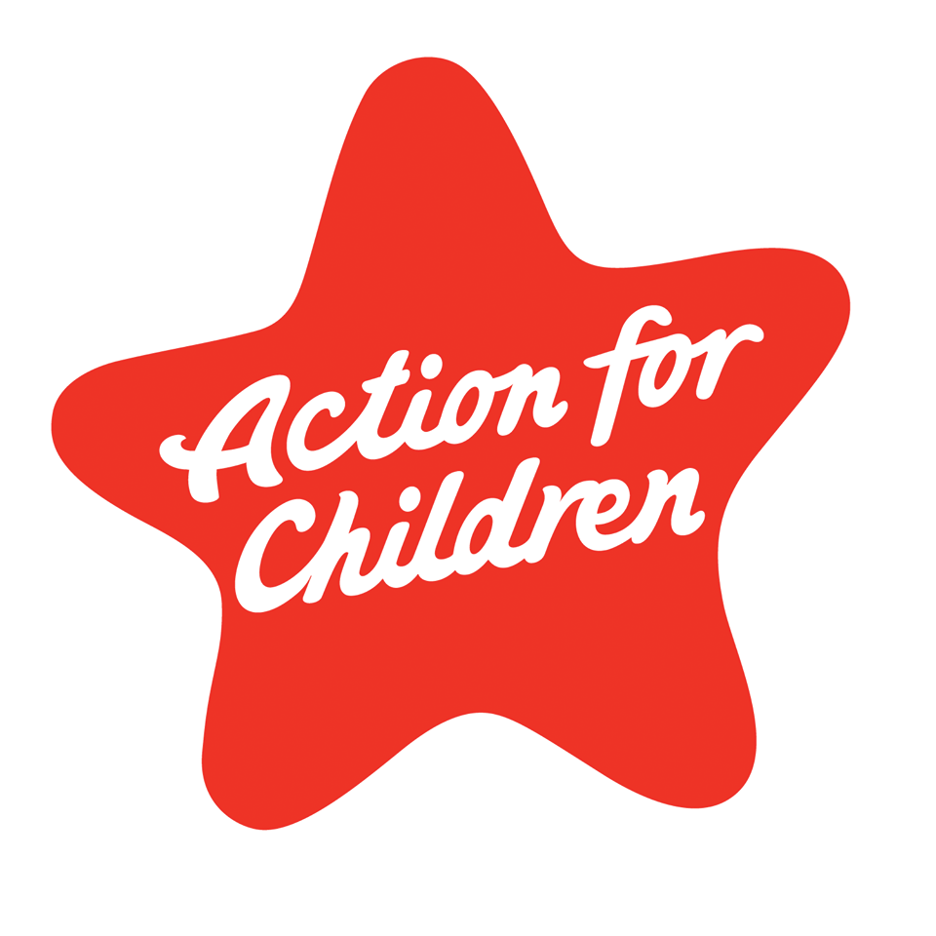  Action For Children | Action for Children is a leading children’s charity running over 500 projects and working with children and young people affected by poverty, disability and abuse.

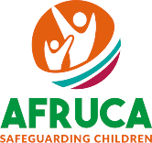  AFRUCA | AFRUCA: (Africans Unite Against Child Abuse)  works in UK Black and Ethnic communities to protect and safeguard children from abuse, modern slavery & exploitation and tackle cultural & religious practices that harm children.  Tel: 0207 704 2261

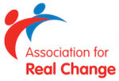  ARC UK | ARC (The Association for Real Change) is a national charity supporting providers of Learning Disability and Autism services, and through a range of projects and services, people with a learning disability, autism, or other additional support needs, and their families.  England: 01246 555 043  Northern Ireland: 028 9038 0960  Scotland: 0131 663 4444

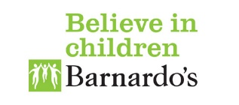  Barnardo's | Barnardo’s work to protect, support and nurture the UK's most vulnerable children by helping families, supporting care leavers, those looking to gain workplace skills, LGBTQ young people and those at risk of homelessness, support children and young people who have been abused and manage fostering and adoption services.

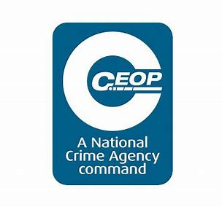  CEOP | CEOP (Child Exploitation and Online Protection) - helps to keep children and young people safe from child exploitation and online sexual abuse and grooming online. It offers guidance, advice and accepts direct reporting with links to a range of information about keeping children across range of ages you know safer from online child sexual abuse.

  Challenging Behaviour Foundation | The Challenging Behaviour Foundation provides telephone and e-mail support from a Family Support Worker on challenging behaviour associated with severe learning disabilities and related issues.  Tel: 0300 666 0126

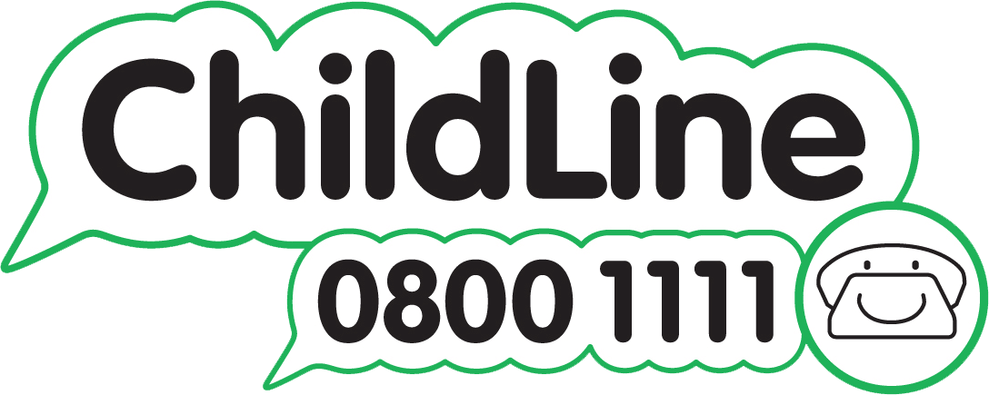  Childline | A free, private and confidential 24-hour service where children and young people up to the age of 19 years old can talk about anything that concerns them with trained counsellors. The website also provides further information e.g. about bullying, feelings, sex.  Tel: 0800 1111

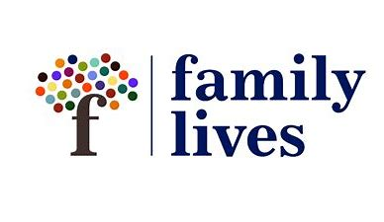  Family Lives | Family Lives (formerly Parentline Plus) is resource for parents, volunteers and workers providing a range of services, including ‘Positive Boundaries’ which focuses on sexual bullying, peer-on-peer sexual exploitation and developing positive gender relationships.  Tel: 0808 800 2222

  The Lucy Faithfull Foundation | Lucy Faithfull Foundation is a UK-wide child protection charity dedicated solely to preventing child sexual abuse. They provide a range of services for organisations, professionals and the public including risk assessments and intervention; expert training; specialist consultancy, and public education.

  NSPCC | NSPCC The NSPCC website has many useful resources, including research studies and fact sheets.  Advice line for parents/adults: 0808 800 5000

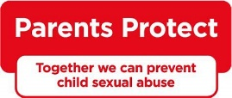  Parents Protect | Parents Protect! Helps parents and carers protect children from sexual abuse and exploitation and has resources to help a family draw up a safety plan and offers confidential helpline support  Confidential helpline - 0808 1000 900

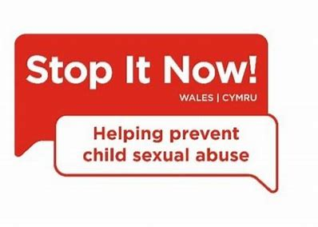  Stop It Now! | Stop It Now! is the Lucy Faithfull child sexual abuse prevention campaign and confidential helpline for any adult concerned about sexual abuse. This helpline will engage with perpetrators of abuse, and so it is a very important resource.  Confidential helpline - 0808 1000 900

Organisations offering support and advice – Vulnerable adults
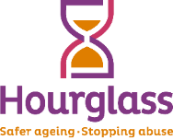  Hourglass | Action on Elder Abuse is now Hourglass  Hourglass’s mission is to end the harm, abuse and exploitation of older people in the UK.  Helpline: 0808 808 8141

  Age UK | Age UK’s website has many useful resources including research studies and fact sheets as well as information on protecting yourself or others from abuse.  Free 24hr advice Line - 0800 678 1602

Organisations offering support and advice – Domestic abuse and violence
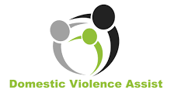  DV ASSIST | Domestic Violence Assist is the UK’s only registered charity specialising in arranging Non-Molestation Orders, Prohibited Steps Orders & Occupation Orders and is available to all, irrespective of gender or sexual orientation  Tel: 0800 195 8699

  FGM – Prevent & Protect | NSPCC | Female Genital Mutilation Helpline A free, anonymous dedicated FGM helpline for anyone worried that a child is at risk of or has already had FGM  Tel: 0800 028 3550

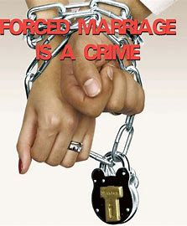  Forced marriage – GOV.UK | Offers advice on how to protect, advise and support victims of forced marriage, including information and practice guidelines for professionals.  There is also a helpline dedicated to supporting British Nationals overseas and in the UK who are affected by or at risk of a forced marriage  Tel: 020 7008 0151  0044 20 7008 0151 if overseas

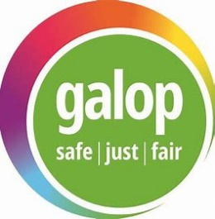  Galop | Galop support LGBT+ people who are victims of domestic abuse, sexual violence, hate crime, so-called conversion therapies, honour-based abuse, forced marriage, and other forms of abuse.  Thay also run a national helpline 0800 999 5428

  Karma Nirvana | Karma Nirvana support victims of honour-based abuse including forced marriage  Tel: 0800 5999 247

  ManKind Initiative | Mankind initiative offers support to men who experience violence from their partners or ex-partners, including a confidential helpline - 01823 334244

  Muslim Women Network (mwnuk.co.uk) | Muslim Women’s Network offer a confidential national specialist faith and culturally sensitive helpline - 0800 999 5786

  National Domestic Abuse Helpline | National Domestic Abuse Helpline, run by Refuge, they offer access to support for women and children experiencing domestic abuse, including to access specialist refuge accommodation  0808 2000 247

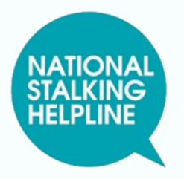  National Stalking Helpline | National Stalking Helpline, run by the Suzy Lamplugh Trust, for victims of stalking, their friends, family and professionals - 0808 802 0300

  Rape Crisis England & Wales | Rape and Sexual Abuse Support Centre offers support for anyone who may have experienced rape or sexual abuse at any time in the life and includes a confidential helpline and online chat  0808 500 2222

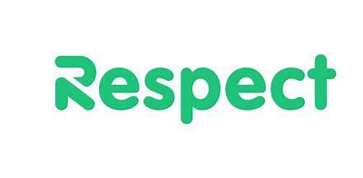  Respect | Home | Respect is the charity that leads on the development of safe, effective work with perpetrators, male victims, and young people using violence in their close relationships  Tel: 0808 8010 327
They also offer a Men's Advice Line to help and support male victims of domestic abuse - 0800 999 5428 |  | Domestic Abuse Helpline for Men

  Restored | Restored offer a safe space for Christian survivors of domestic abuse. Their mission is to “To Speak Up about the realities of violence against women and girls, and to Equip the Church to stand against domestic abuse and Support Survivors”, and they offer a guide for churches to address domestic abuse.

  Women's Aid | Women’s Aid are working to improve society’s response to domestic abuse to ensure that every survivor gets the support they need, whoever and whenever they ask for help  24/7 free helpline 0808 2000

Organisations offering support and advice – Survivors of abuse
  MACSAS | MACSAS (Minister and Clergy Sexual Abuse Survivors) supports women and men who have been sexually abused, as children or adults, by ministers, clergy or others under the guise of the Church, whether they have remained within their Christian communities or have chosen to leave.  Freephone: 08088 01 03 40

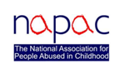  NAPAC | NAPAC (National Association of People Abused in Childhood) offers support to adult survivors of all types of childhood abuse, including physical, sexual and emotional abuse and neglect.  Freephone: 0808 801 0331

  OneinFour | One in Four specialises in supporting survivors of sexual violence and abuse, particularly survivors of child sexual abuse and trauma through counselling, advocacy and through the judicial system  Tel: 0208 697 2112

  Home - Replenished | Replenished Life are an independent charity which supports those who have experienced abuse and trauma within faith  07746 153703

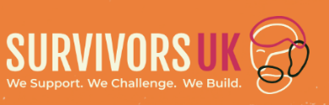  SurvivorsUK | SurvivorsUK offer support for man, boy or non-binary person survivors of rape or sexual assault and their families  Helpline -020 3598 3898

Organisations offering support and advice – Mental Health
  Every Mind Matters | Better Health: every mind matters - offers expert advice and practical tips to help maintain mental wellbeing.

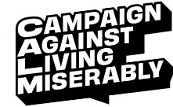  CALM | CALM (the Campaign Against Living Miserably) is leading a movement against suicide offering website advice and a free, confidential helpline about a whole range of concerns, such as anxiety, relationship concerns, health worries, money worries or suicidal thoughts.  Helpline: 0800 58 58 58

  Mental Health Foundation | Mental Health Foundation offer online support including information, one-to-one support, online communities, smartphone apps, online self-help programs and online therapy.

Mind | Mind offer information and support for anyone living with or supporting someone with a mental health problem.  Infoline: 0300 123 3393

  Papyrus Prevention of Young Suicide | Papyrus – is a charity dedicated to the prevention of suicide and the promotion of positive mental health and emotional wellbeing in young people.  They also run HOPELINE247, a confidential support and practical advice helpline for any young person having thoughts of suicide or for anyone concerned that a young person might be  Tel: 0800 068 4141 Text: 07860039967

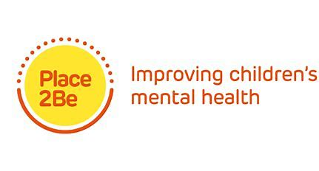  Place2Be | Place2Be – offers support and training for parents and schools in managing children’s mental health  Tel: 020 7923 5500

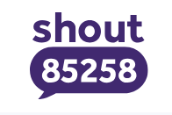  Shout - UK's 24/7 Crisis Service | Shout is the UK's first and only free, confidential, 24/7 text messaging support service for anyone who is struggling to cope.  Text SHOUT to 85258

  YoungMinds | YoungMinds – offer support and guidance for young people and their parents/carers when they are struggling with their mental health, providing a helpline and webchat for parents.  Tel: 0808 802 5544

Organisations offering other support and advice
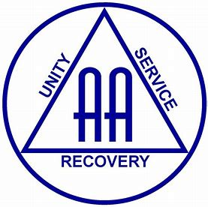  Alcoholics Anonymous Great Britain | Alcoholics Anonymous support the personal recovery and continued sobriety of individual alcoholics.  Tel: 0800 917 7650

  Drinkaware | Drinkaware - provides advice and information to help people learn about the impact of alcohol on them, their family or friends  Drinkline national alcohol helpline 0300 123 1100

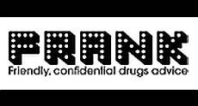  Honest information about drugs | FRANK | Frank: Drug and Alcohol Helpline 24/7  Tel: 0300 123 6600  Text 82111

  GambleAware | Gamble aware -provides free, confidential and personalised support for anyone who’s experiencing problems from gambling, as well as those affected by someone else’s gambling.  National Gambling Helpline 0808 8020 133

  Mencap | Mencap Learning Disability Helpline provides advice and information on all issues relevant to people with learning disabilities and their families in England, Wales and Northern Ireland.  Tel: 0808 808 1111

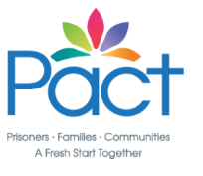  Prison Advice and Care Trust | Pact (Prison Advice and Care Trust) supports prisoners, people with convictions, and their children and families at every stage of the criminal justice process.

  Respond | Respond is a national charity supporting children and adults with learning disabilities who have experienced abuse or trauma. Respond provides therapeutic support as well as practical advice and information.  Tel: 0207 383 0700

  Samaritans | Samaritans are there to talk to, no matter how small the issue may feel to be; they will listen, won't judge or say what to do. They offer a confidential service covering a range of areas, not just for those who are feeling suicidal.  Tel: 116 113

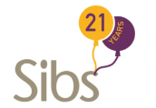  Sibs | Sibs provides information and support to people growing up with – or have grown up with – a sibling with any disability, long term chronic illness or life limiting condition.

  Stop! Think Fraud | Stop! Think Fraud is a government website providing information on all aspects of fraud, from protecting yourself to reporting suspicions.

  Home | The Traveller Movement | The Traveller Movement advocates for and works with Romani (Gypsy), Roma & Irish Traveller people to tackle discrimination and promote equality  Tel: 020 7607 2002

  Our mission - Unlock | Unlock – is a support and advocacy service to help those people in England and Wales with a criminal record to move on with their lives

  Unseen | Unseen provide support for survivors of trafficking and modern slavery and run the modern slavery & exploitation Helpline working to stamp out slavery for good.  Tel: 08000 121 700

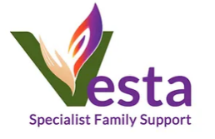  Vesta - Specialist Family Support | Vesta – works to empower Polish Families in England and Wales and was formerly known as the Polish Domestic Violence Helpline  Tel: 07545 075093

  Women in Prison | Women in Prison is a national charity providing specialist support services for women affected by the criminal justice system and campaigns to end the harm caused to women, their families and our communities by imprisonment.  Tel: 020 7359 6674

