Managing information
Confidentiality

- The duty of confidentiality is one of common law, which means it comes from caselaw, as opposed to statute.

- However, emergency or life-threatening situations may warrant the sharing of relevant information with the relevant emergency services without consent.

The basics of confidentiality in the Church

- Things people share should be treated in confidence.

- Do not assume that a person's friends or family know any details.

- Confidentiality is just as important with children as with adults.

- Do not share information without express permission, even in open prayer or intercessions.

- If you know someone in more than one context, remember to keep the boundaries.

- If you believe someone to be at risk disclose the information only to the relevant authorities.

- The limits of confidentiality should be set by open and agreed policy rather than assumption.

For further information see section 7.1.1 Confidentiality - Safeguarding Policy, Procedures and Guidance for the Methodist Church in Britain

Consent
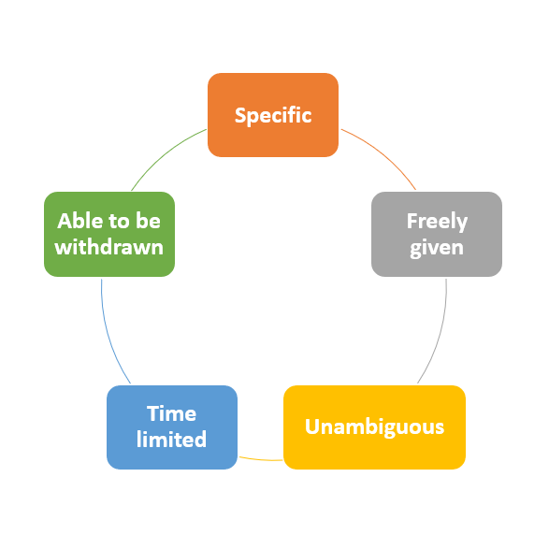
Standard: consent must be
- specific

- freely given

- unambiguous

- time limited

- able to be withdrawn

Grounds for sharing information without consent

- where it is legally required e.g. because the law or a court order directs it
- where there is an overriding and specific public interest in disclosure e.g. where the sharing is necessary for safeguarding purposes
- disclosure outweighs the public interest in maintaining confidentiality

- the disclosure is proportionate i.e. no more than necessary

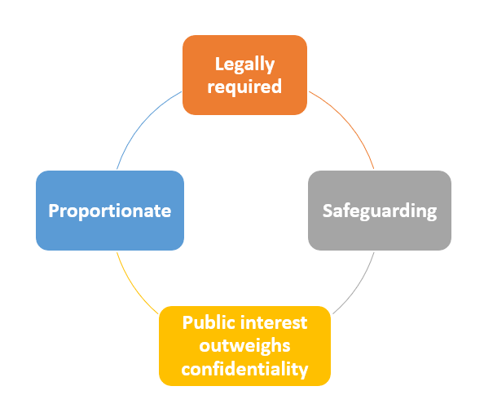

If you are in a situation where you feel that you have to disclose information without consent, you must record your decision and the reasons for making it.

  - Identify the protocols/guidance that you referred to and who you consulted about this decision.

  - Clearly record the legal basis for sharing without consent in each particular case.

  - Record what information is to be shared and with whom.

  - Record why there is a pressing need to share and whether the sharing is proportionate.
  - Consider any potential impact on the individual whose information is being shared.

If in doubt, always seek advice

Data protection and GDPR

- Information can be shared lawfully within the limitations of the Data Protection Act 2018 and the General Data Protection Regulation (GDPR).

- The General Data Protection Regulation (GDPR) and Data Protection Act 2018 enables organisations to collect personal information provided it is required for a specific purpose and disposed of when no longer needed or relevant.

- TMCP (Trustees for Methodist Church Purposes) have compiled detailed information that explains the duties imposed on Managing Trustees in relation to the data held by local churches, circuits and districts under Data Protection legislation and guidance

see www.tmcp.org.uk/about/data-protection

- The law does not prevent the sharing of sensitive, personal information within organisations. If the information is confidential, but there is a safeguarding concern, sharing it may be justified.

- The law does not prevent the sharing of sensitive, personal information between organisations where the public interest served outweighs the public interest served by protecting confidentiality – for example, where a serious crime may be prevented.

- There should be a local agreement or protocol in place setting out the processes and principles for sharing information between organisations.

The eight key data protection principles
1. Be open about personal data practices
2. Collection of personal data must be limited, lawful and fair
3. Purpose of collection and disclosure must be specified
4. Use of data must be for the purpose specified
5. Personal data must be subject to appropriate safeguards
6. Personal data must be relevant, accurate and up to date
7. People must be able to access and correct their data
8. Data controllers must comply with the data protection principles

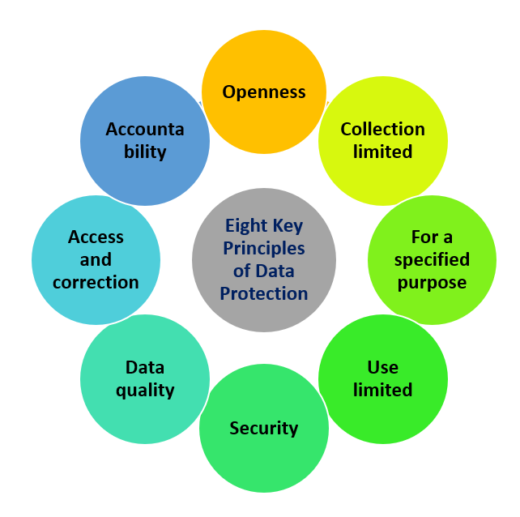

Seven golden rules for information sharing

1. Remember that the Data Protection Act is not a barrier to sharing information
2. Be open and honest
3. Seek advice where necessary
4. Share with consent where possible and respect the wishes of those who do not wish to consent if appropriate
5. Always consider safety and wellbeing; of the individual and others
6. Ensure information shared meets the principles to the left
7. Record your decision; whether this is to share or not

