Other Guidance
References  below relate to Safeguarding Policy, Procedures and Guidance for the Methodist Church in Britain (July 2023)
P – these pages numbers relate to this section
Anti bullying |  | Appendix 1 anti-bullying policy-july-2023.pdf (methodist.org.uk)
Character References |  | Appendix 5b |  |  |  |  |  |  |  |  | character reference requests july_2023.pdf (methodist.org.uk)
 |  | Briefing Sheet on Safeguarding and Character References |  |  |  |  |  |  |  |  |  |  |  |  |  |  |  |  |  |  |  |  |  |  |  |  |  |  | P6
Children, Youth & Family Ministry |  |  |  |  |  |  | Equipping and resourcing ministry to and with children, young people, families and young adults. |  |  |  |  |  |  |  |  |  |  |  |  |  |  |  |  |  | Children, Youth & Family Ministry (methodist.org.uk)
Code of safer working practices when working with children and young people |  |  |  |  |  |  |  |  |  |  |  |  |  |  |  |  |  |  | Section 3.1 |  |  |  |  |  |  |  |  | P9
Code of safer working practices when working with children and young people leaflet - Jan 2024 |  |  |  |  |  |  |  |  |  |  |  |  |  |  |  |  |  |  |  | safer_working_practices_cyp_leaflet_final-jan_2024.pdf (methodist.org.uk)
Code of safer working practices when working with adults |  |  |  |  |  |  |  |  |  |  |  |  |  |  |  |  |  |  |  |  |  |  | Section 3.2 |  |  |  |  |  |  | P12
Code of safer working practices when working with adults leaflet - Jan 2024 |  |  |  |  |  |  |  |  |  |  |  | safer_working_practices_with_adults_leaflet-jan_2024.pdf (methodist.org.uk)
Complaints | Model Church Safeguarding Policy section h - Complaints procedure |  |  |  |  |  |  |  |  |  |  |  |  |  |  |  |  |  |  |  |  |  |  |  |  |  |  | P14
Complaints and Discipline |  |  |  |  |  |  |  |  | Complaints and Discipline (methodist.org.uk)
Consent |  | Information Sheet and Consent Form for Young People (13 and Over) - Updated May 2022 |  |  |  |  |  |  |  |  |  |  |  |  |  |  |  |  | photography video consent form YP 13+may_2022.docx (live.com)
 |  | Information Sheet and Consent Form for Parents and Carers - Updated May 2022 |  |  |  |  |  |  |  |  |  |  |  |  |  |  |  |  | Photography and Video (parents carers)
Data Protection |  |  | Data Protection - Trustees for Methodist Church Purposes (tmcp.org.uk)  Data protection (methodist.org.uk)
Dementia Friendly Churches |  |  |  |  |  |  |  |  |  |  |  |  |  |  |  |  |  |  |  | Dementia Friendly Churches
Domestic Abuse |  |  | 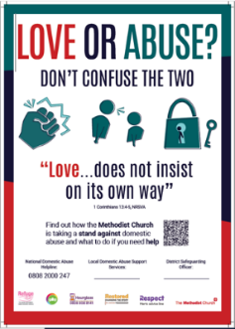 |  |  |  |  |  |  |  |  |  | Domestic Abuse Poster – Sept 2022 |  |  |  |  |  |  |  |  |  |  |  |  |  |  | Domestic Abuse Poster
 |  |  | Domestic Abuse Stickers  Sheets of 12 stickers can be ordered free from Methodist Publishing; you just pay P&P |  |  |  |  |  |  |  |  |  | 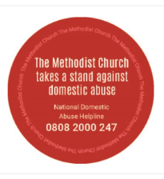 |  |  |  |  |  |  |  |  |  |  |  |  |  |  | Domestic Abuse sticker sheets
External Users' safeguarding policy declaration agreement-March 2023 |  |  |  |  |  |  |  | Appendix 10- Safeguarding Policy, Procedures and Guidance for the Methodist Church in Britain (July 2023) |  |  |  |  |  |  |  |  |  |  |  |  |  |  |  | external users july_2023.pdf (methodist.org.uk)
Policy and guidance for working with victims and survivors- November 2023 |  |  |  |  |  |  |  |  |  | working with victims and survivors nov_2023.pdf (methodist.org.uk)
Safeguarding Guidance for Local Ecumenical Partnerships (LEPs) -July 2023 |  |  |  |  |  |  |  |  |  |  |  |  |  |  |  |  |  |  |  | SG guidance LEPs july_2023.pdf (methodist.org.uk)
Safer Working Practices When Managing Children’s Activities |  |  |  |  | Appendix 2 - Safeguarding Policy, Procedures and Guidance for the Methodist Church in Britain (July 2023) |  |  |  |  |  |  |  |  |  |  |  |  |  | safer working practice childrens activities july_2023.pdf (methodist.org.uk)
Safeguarding Forms |  |  |  | Safeguarding Concern Form – to help you collect the necessary information when you receive information |  |  |  |  |  |  |  |  |  |  |  |  |  |  |  |  |  | Church Safeguarding Concern Form
Safeguarding Podcasts |  | Domestic Abuse: Coercive Control, April 2023  Sexual Harassment - An interview with Dr Jane Meyrick, Feb 2023  The Methodist Podcast Episode 62, July 2021 |  |  |  |  |  |  |  |  |  |  |  |  |  |  | 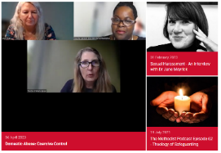 |  |  |  |  |  |  |  |  |  |  | Safeguarding Podcasts
Safeguarding Posters |  | 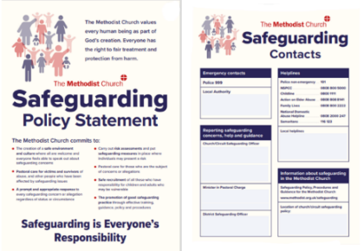 |  |  |  |  |  |  |  |  |  |  |  | These Methodist Church Safeguarding Commitments and Key Contacts Posters should be displayed in a prominent location in every church. |  |  |  |  |  |  |  |  |  |  |  |  |  | Safeguarding Commitments Contacts Poster
Safeguarding Training |  | 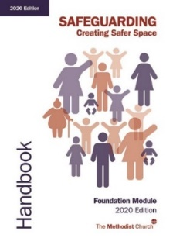 |  |  |  |  |  |  | Materials for participants of Foundation Module:  - Who should attend - Updated October 2021  - Privacy Notice - March 2023  - Handbook  - Participant Workbook  - Feedback Form |  |  |  |  |  |  |  |  |  |  |  |  |  |  |  |  |  |  | Foundation Module 2020 Edition (Participants)
 |  | Materials for participants of Advanced Module:  - Who should attend  - Updated May 2023  - Privacy Notice - March 2023  - Handbook  - Workbook  Also available to download on MCBX for online participants  - Preparing the Ground  (Face to face training only)  - Feedback Form |  |  |  |  |  |  |  |  |  |  |  |  |  |  |  | 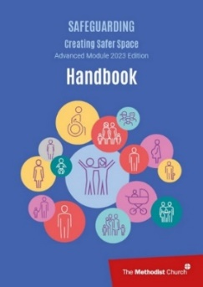 |  |  |  |  |  |  |  |  |  | Advanced Module 2023 Edition (Participants)
Safeguarding Webinars |  | - Trauma and the Impact on Survivors - Sept 2023  - Safeguarding People who are LGBT+ in the Methodist Church – Jan 23  - The Hidden Victims of Domestic Abuse - Nov 2022  - Signs and Indicators of Child Sexual Abuse - Nov 2022  - Financial Abuse Webinar - June 2022  - Speaking Truth: Voices of Survivors of Child Abuse - Jan & Feb 2022  1: Hearing Reality: Voices Crying in The Wilderness  2: The Church’s Response to Survivors: From Stumbling Block to Stepping Stone  - Bullying Webinars - 2022  1: Tackling Bullying, Changing Culture, Enabling Positive Relationships  2: Reconciling communities: living well with difference  3: Addressing Bullying through Justice, Dignity and Solidarity  - Making Our Churches More Dementia-Friendly Webinar: Nov 2021  - Domestic Abuse - Nov 2021  - Domestic Abuse - Nov 2020 |  |  |  |  |  |  |  |  |  |  |  |  |  |  |  |  |  |  |  |  |  |  |  |  |  | Safeguarding Webinars (methodist.org.uk)
Spiritual Abuse |  |  |  |  |  | Spiritual Abuse Resources |  |  |  |  |  |  |  |  |  |  |  |  |  |  |  |  |  |  |  |  | Spiritual Abuse
Survivors |  | 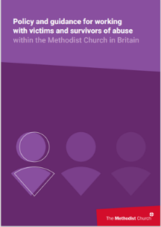 |  |  |  |  |  |  | Policy and guidance for working with victims and survivors within the Methodist Church. |  |  |  |  |  |  |  |  |  |  |  |  |  |  |  |  | policy and guidance for working with victims and survivors nov_2023.pdf (methodist.org.uk)
Survivors Policy - A Short guide for victims and survivors - November 2023 |  |  |  |  |  |  |  |  | survivors policy short guide nov_2023.pdf (methodist.org.uk)
Survivors study guide |  | 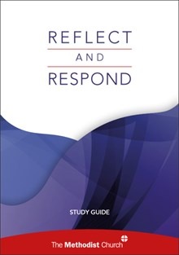 |  |  |  |  |  |  | Reflect and Respond study guide-  for use with small groups and provides case study material, theological commentary and challenging questions |  |  |  |  |  |  |  |  |  |  |  |  |  |  |  |  |  |  | Reflect and Respond study guide  Reflect and Respond Leaders Guide
Further copies can be ordered free of charge from Methodist Publishing; you just pay P&P
Safeguarding Survivors Study Guide

Survivors leaflet |  | Supporting survivors of abuse  Short leaflet explaining what those who choose to make a disclosure can expect from the church |  |  |  |  |  |  |  |  |  |  |  |  | 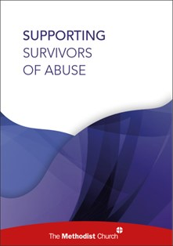 |  |  |  |  |  |  |  |  |  |  |  |  | Supporting Survivors of Abuse leaflet
Further copies can be ordered free of charge from Methodist Publishing; you just pay P&P

Safeguarding Survivors leaflet

The Theology  of Safeguarding |  | 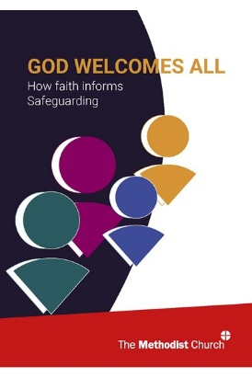 |  |  |  |  |  |  | God Welcomes All study guide. |  |  |  |  |  |  |  |  |  |  |  | God Welcomes All How faith informs safeguarding
The Well Learning Hub |  | Learning opportunities, resources and support for anyone working with children, young people and families |  |  |  |  |  |  |  |  |  |  |  |  |  |  | The Well Learning Hub - equipping and supporting workers (methodist.org.uk)
Ukraine |  | Guidance on hosting Ukrainian people in Methodist residential property as part of the Government’s ‘Homes for Ukraine’ scheme |  |  |  |  |  |  |  |  |  |  |  |  |  | Homes for Ukraine Checklist -TMCP
 |  | Information on the Methodist Church’s response to the crisis in Ukraine and how churches can help |  |  |  |  |  |  |  |  |  |  |  |  |  | Toolkit for churches responding to the crisis in Ukraine (methodist.org.uk)
Whistleblowing |  | Methodist whistleblowing policy (2019) |  |  |  |  |  |  |  |  |  |  |  |  |  |  |  |  | Discipleship & Ministries document (methodist.org.uk)
 |  | Whistleblowing for employees: What is a whistleblower - GOV.UK (www.gov.uk)
Wi-Fi use |  | Guest Wi-fi Acceptable Use Policy |  |  |  |  |  |  |  |  |  |  |  | guest wifi acceptable use policy february_2021.docx (live.com)

Briefing Sheet on Safeguarding and Character References

This factsheet has been produced to provide further information about character references and the potential safeguarding impact when they are provided by individuals with reference to the Methodist Church or acting on behalf of the Church.

1. What is a character reference?

A character reference is a statement in which a person with knowledge of another, provides comment about their personality or behaviour. This is likely to include drawing conclusions about their disposition or presentation. This is different from an ordinary request for a statement of fact, such as when a police officer takes a statement to evidence a crime. The defining difference is that between known fact of circumstances and personal judgement of character.

2. When could I receive a request to provide a character reference?

In the majority of cases, defence solicitors will be seeking character statements to try to provide evidence of good character. The aim is to balance the prosecution case in court or to influence sentencing if the person has already been found guilty.

However, you may be called to provide character references for employment tribunals, immigration processes (e.g. applications for citizenship or right to remain in the UK) or in relation to employment matters or proceedings. Some parties have also been requested to provide character references during meetings with statutory agencies such as social care relating to safeguarding adults and children.

3. Why are character references so sensitive in safeguarding concerns?

a) The impact on survivors
The desire to stand by those who have long association with the Church and are known personally to congregations can be a strong call to action. However, survivors should be able to expect that the Church stands by them in public and private. The words and actions of the Church should clearly acknowledge the impact of abuse on survivors and condemn those acts, rather than seeking to counterbalance what has been suffered and minimize the impact of the application of justice. Many survivors in congregations feel unable or do not wish to publicly share the harm they have suffered. They may suffer further pain and isolation if character references are made by those connected to the Church in a public arena, which seek to present those who are alleged to have carried out abuse in a positive light.

b) The impact on the individual giving the statement
While character statements are given with the best of intentions, they are often not based on fact and may over-emphasise positive attributes or behaviours. These comments may not be borne out by very limited interaction with the subject of the statement. Those who give character references should expect that they might be called to provide further detail in court or other environments to evidence what they have said. They may also expect an impact on their personal credibility if they have made public judgements about character, which are later found to be contrary to the known facts. The evidence of someone connected to the Methodist Church might be given greater weight due to the moral expectations of the public. Great care should be given in providing any public statement of this nature.

c) The impact on the congregation
The Past Cases Review identified many cases where congregations were torn apart or people damaged by failing to apply appropriate respectful uncertainty to circumstances where safeguarding allegations are made. Where a crusade to support an individual goes beyond appropriate pastoral support, divided opinions may damage communities and isolate individuals. The provision of character references can play a part in this.

d) The impact on the Methodist Church
Those who have recently viewed the BBC’s series on the Peter Ball case in the Church of England will be aware of the reputational damage to the Church and the monarchy that is likely to result in over-optimistic statements being made about the character of those facing abuse allegations. The perception of survivors and the wider public is that the Establishment supported abusers and colluded to avoid the scrutiny of public authorities. While welcoming everyone and making provision for those who may present a safeguarding risk, the Methodist Church condemns abuse and recognizes the devastating impact that may be suffered by survivors who are harmed by engagement in church activities. The provision of character statements can risk diluting this message and counter the efforts of all in the Church to build trust and confidence.

4. What should I do if someone asks or suggests that I should give a character reference linked to my knowledge of someone through the Methodist Church that may be relevant to safeguarding concern?
Clearly define with the person requesting you to provide a character reference what they expect of you and whether this is as a representative of the Methodist Church. Find out whether it may be linked to formal proceedings, attendance at a meeting or the submission of a written report. Confirm whether they are seeking a factual account of circumstances e.g. someone’s attendance at church or your personal judgement. Avoid agreeing your involvement before you have taken further advice.

Always contact your District Safeguarding Officer as soon as possible, regardless of who has made the request. They will be able to provide guidance about current policy and procedures and give support. They will also be able to help you explain the Methodist Church’s policy on character references.
The Safeguarding Policy, Procedures and Guidance for the Methodist Church (2019) notes that the lay office holders, employees or ministers should only give character statements in exceptional circumstances and then only with the input of the DSO and/or lay employment adviser (where applicable).

While members who are not office holders, employees or ministers may make personal decisions about the provision of character statements in a personal capacity, they are advised not to do and to take guidance from the DSO. It is important that careful consideration be given to the potential impact to themselves and others before taking action. If giving a statement in a personal capacity, it should be clearly stated in the statement that it does not represent the opinion of the Church and is done so in a personal capacity only.

The Church will always work in partnership with statutory agencies to support safeguarding processes. The information provided in this document does not affect those situations where a party connected to the Church is legally required to provide information or attend proceedings in order to confirm a factual account.

Code of Safer Working Practice with Children
Section 3 Safeguarding Policy, Procedures and Guidance for the Methodist Church in Britain
3.1.1 Appropriate conduct
Church officers will respect all children, young people and adults and promote their well-being.

The Church will create and maintain environments that:
• are safer for all
• promote well-being
• prevent abuse
• create nurturing, caring conditions within the Church for children, young people and adults.

It will work to continue to strengthen and review these environments. This will be done by training, support, communication, learning and quality assurance processes.

The Church will challenge any abuse of power within church communities by ensuring church officers adhere to safe working practice, and are supported in challenging bullying and abusive behaviour. It will ensure that children, young people and adults will be listened to, supported and will know that they will receive care.

You should:
• be aware of and understand the local safeguarding policy
• treat all children and young people fairly and without prejudice, discrimination or
favouritism
• respect differences in gender, sexual orientation, culture, race, ethnicity, disability and
faith and challenge behaviour that demonstrates discrimination and/or prejudice
• ensure that your own language, tone of voice and body language is respectful
• always aim to work with or within sight and hearing of another adult
• ensure that another adult is informed if a child needs to be taken to the toilet (toilet
breaks should be organised for young children)
• ensure that children and young people know who they can talk to or contact if they need to speak to someone about a personal concern and encourage them to speak out if they feel uncomfortable or concerned. They should be made aware of organisations that can provide support.
• respond warmly to a child who needs comforting but this should not involve physical
comfort e.g. cuddles.
• advise children, young people and their parent/carers/guardians in advance if any
activity requires physical contact and provide an opportunity to opt out or agree
alternative activities.
• administer any necessary first aid with others around
• obtain consent for any photographs/videos to be taken, shown or displayed via any
medium. (This should be from the parent, carer or guardian and the young person if 12
years or over. Images should not be taken or stored on personal devices).
• record any incidents that concern you or make you feel uncomfortable and give the
information to your group leader in the first instance. Although you must also contact the church, circuit or district safeguarding officer immediately if you believe you have acted in a way which others may have interpreted as inappropriate or if a child has acted
inappropriately towards you. Records must be signed and dated.
• always share concerns about a child or the behaviour of another worker with your group leader and/or the safeguarding officer.

You should not:
• initiate physical contact and if this is initiated by the child, do not pull away abruptly but do so gently so physical contact is for the minimum amount of time
• invade a child’s privacy whilst they are washing or using the toilet
• play rough physical or sexually provocative games
• use any form of physical punishment
• be sexually suggestive in the presence of or to a child, even as a joke
• touch a child inappropriately or forcefully
• scapegoat, ridicule, reject or ignore a child, group or adult
• allow abusive peer activities (e.g. initiation ceremonies, ridiculing or bullying)
• show favouritism to any one child or group
• allow a child or young person to involve you in excessive attention-seeking that is clearly physical or sexual in nature
• give lifts to children or young people on their own or on your own
• smoke any substance, vape or consume alcohol in the presence of children or when
responsible for them
• provide personal contact details to a child or young person such as mobile number,
email or social media contact
• share sleeping accommodation with children
• arrange social occasions (this includes online activity) with children or invite them to your home outside organised group occasions (other than with the consent of parent, carers or guardians and where at least one other adult is present)
• allow unknown adults access to children (visitors should always be accompanied by a known person)
• allow strangers and those who are not authorised to give children lifts.

3.1.2 Appropriate dress
You should dress appropriately when working with children and not wear anything revealing or that is not practical for carrying out the tasks as part of your role.

3.1.3 Receiving gifts
There may be occasions when children give you gifts. It is polite to accept a gift but your group leader should be informed. If you receive any gift of significant value, e.g. more than £15.00, you should talk with your group leader about whether it is appropriate to accept it. As a general rule, expensive gifts should not be accepted.

For further guidance on procedures for safer working practices when managing activities for
children, please refer to Appendix 2.

Code of Safer Working Practice with Adults

Taken from Section 3 - Code of Safer Working Practices with Children, Young People and Vulnerable Adults Safeguarding Policy, Procedures and Guidance for the Methodist Church in Britain (July 2023)

Appropriate conduct

You should:
- treat all adults with respect and dignity

- ensure that your own language, tone of voice, and body language are respectful record any incidents of concern and give the information to your group leader, sign and
date the record

- share concerns about an adult or the behaviour of another worker with your group leader and/or safeguarding officer.

You should not:
- invade the privacy of an adult who is washing and toileting

- use any form of physical punishment or restraint (apart from car seat belts)

- be sexually suggestive about or to an adult, or scapegoat, ridicule or reject an adult or
group

- permit abusive peer activities (e.g. initiation ceremonies, ridiculing or bullying)

- show favouritism to any one adult or group

- allow an adult to involve you in behaviour that is overtly physical or sexual

- allow unknown adults access to adults deemed at risk of harm (visitors should always be
accompanied by a known person)

- allow strangers to give lifts to adults in your group.

Visiting adults at home

- Most visits to adults in their own home will be straightforward as they will be well known
to the church. However, when visiting someone new for the first time, visitors should let
someone else know whom they are visiting (and when).

- Visiting in twos may be advisable, especially if the adult lacks capacity. It is also
advisable to take a mobile phone.

- Do not call unannounced. Call by appointment, telephoning the person just before
visiting if appropriate.

- Be clear about what support can be offered to the adult if they ask for help with particular problems and refer back to the church if uncertain.

- Do not make referrals to any agency that could provide help without the adult’s
permission, and ideally encourage them to set up the contact.

- Never offer ‘over the counter’ remedies to people on visits or administer prescribed
medicines, even if asked to do so.

- Do not accept any gifts from adults other than token items, to avoid misunderstandings or subsequent accusations from the person or their family.

- If someone wants to make a donation to the church, put it in an envelope, mark it on the outside as a donation and obtain a receipt from the treasurer.

- Pastoral visitors should note the date when they visit people, report their visit to the pastoral secretary and say what is concerning or going well.

If You Have a Concern or Someone Tells You Something
- If the person is in immediate danger ring 999.

- Do not try to put the person off from speaking to you now as it may have taken them a great deal to reach this point. However, it may be necessary to find a suitable place to listen.

- Offer reassurance that disclosing is the right thing to do.

- Stay calm and listen carefully with undivided attention. Do not put words into their mouth.

- Do not make judgement, express shock or disbelief and do not minimise what they are telling you.

- Do not make promises you cannot keep.

- Do not promise confidentiality but explain what you will do with the information.

- Either during (if appropriate) or afterwards, make notes of what was said or seen, including the date, time, venue and the names of people who were present and sign it.

- Always report to the appropriate Minister or Safeguarding Officer within 24 hours
- Do not conduct any enquiries yourself or talk to anyone else involved.

The Foundation Module Safeguarding Handbook contains a lot of detailed information about recognising abuse, responding well, recording what has happened or been said and referring to an appropriate person.
Always remember you are not alone and can make immediate contact with someone for support if you need to do so. This may be a colleague, a Minister, or a Safeguarding Officer

Complaints procedure

Taken from: Model Church Safeguarding Policy section h - Complaints procedure

There is a formal complaints procedure within the Methodist Church, which allows concerns to be raised about actions or behaviour by a member or officer of the Church. In addition, employed staff will be subject to relevant contractual procedures. All complaints will be responded to with care, diligence and impartiality. A complaint should be addressed to the superintendent minister, the Revd. [NAME]. If a complaint is made to another person it should be referred to the superintendent. Meetings will be arranged with the person making the complaint and, usually, the person against whom the complaint has been made, in an attempt to resolve it. If the complaint is against the superintendent, it should be sent to the District Chair, the Revd. [NAME] at [ADDRESS]. Safeguarding officers must be informed of any complaint or issue relating to the potential abuse of children, young people or adults who may be vulnerable. They will support prompt action to respond to the circumstances of any safeguarding concern, whether or not any party involved wishes to make a formal complaint through the Methodist Church.

