Policy, Procedure and Guidance
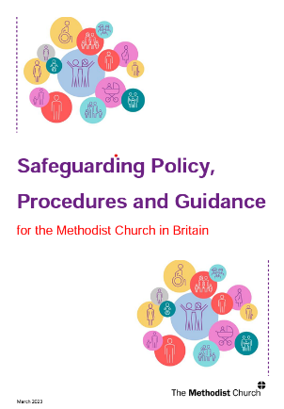
Safeguarding Policy, Procedures and Guidance for the Methodist Church in Britain is just one of the documents that sets out the policy, procedures and guidance relating to safeguarding within the Methodist Church. The provisions outlined are informed by current legislation and accepted good practice from within the Church, statutory agencies and other community organisations with safeguarding responsibilities.

The requirement for the Church to have such a document is laid down in legislation:

Children
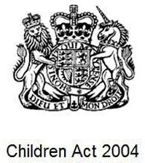
Working Together to Safeguard Children 2023
Voluntary, charity, social enterprise, faith-based organisations and private sectors
Section 11 of the Children Act 2004

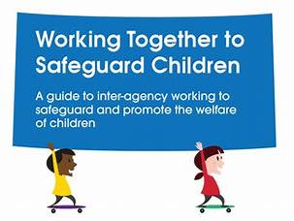

Like other organisations and agencies who work with children, they should have appropriate arrangements in place to safeguard and protect children from harm. Many will also be subject to charity law.

The Children Act 2004 places a duty on the local authority to promote co-operation with partners and other agencies in order to improve the wellbeing of children in their area. It also places duties on a range of organisations and individuals to ensure they, too, give sufficient regard to children in need of help and safeguarding.

Every VCSE, faith-based organisation and private sector organisation or agency should have policies in place to safeguard and protect children from harm. These should be followed, and systems should be in place to ensure compliance in this.
All practitioners working in these organisations and agencies who are working with children and their families are subject to the same safeguarding responsibilities, whether paid or a volunteer.

Adults
The Care Act 2014 - Sections 42 to 46 cover safeguarding

Although local authorities hold the main legal duty to safeguard adults, anyone who works with adults at risk and has concerns must pass these onto the local authority.
The local authority then has responsibility to make enquiries.
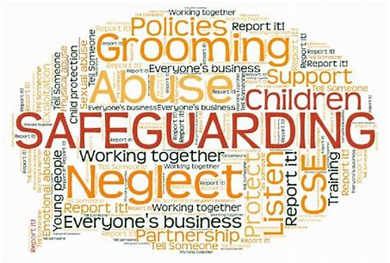
This means that for our safeguarding practice to be effective we also need to understand and be sensitive to all those factors, including economic and social circumstances and ethnicity, which can impact the lives of those we come into contact with.

Other relevant child safeguarding guidance
National Independent Child Safeguarding Practice Review Panel - Child Protection in England National review into the murders of Arthur Labinjo- Hughes and Star Hobson. |  | The review argues that multi-agency arrangements for protecting children are more fractured and fragmented than they should be and propose a new approach to managing child protection work. | Child Protection in England - May 2022
Stable Homes, Built on Love | is a strategy and consultation for transforming children’s social care which aims to help families overcome challenges at the earliest stage, keep children safe from significant harm, and ensure children in care have stable, loving homes and long-term relationships. |  | Children's social care stable homes built on love consultation

Children’s Social Care National Framework | is statutory guidance from the Department for Education and is central to setting direction for practice in children’s social care as part of the reforms set out in Stable Homes, Built on Love | Children's social care national framework

Guidance for charity trustees

Charity trustees are responsible for ensuring that those benefiting from, or working with, their charity, are not harmed in any way through contact with it. The Charity Commission for England and Wales provides guidance on charity compliance which should be followed.

The Charity Commission (2018) expects that:

Safeguarding should be a governance priority for all charities. |  | Trustees should ensure their charity provides a safe environment and protects staff, volunteers, and anyone who comes into contact with it from abuse or maltreatment of any kind. |  | Trustees should take steps to ensure no one who comes into contact with their charity suffers distress or harm, as well as safeguarding children and adults at risk.

The Charity Commission has produced detailed safeguarding guidance that sets out the specific responsibilities for voluntary organisations and is also good practice even if your organisation is not a charity, because these are standards the public will expect.

For further organisational policy guidance see

section 12 Other Methodist Guidance

Managing Trustees (methodist.org.uk)

Further guidance for charity trustees

 | Strategy for dealing with safeguarding issues in charities - GOV.UK (www.gov.uk)  Safeguarding for charities and trustees - GOV.UK  Safeguarding and protecting people for charities and trustees - GOV.UK  5-minute guides for charity trustees - GOV.UK
The essential trustee: what you need to know |  | 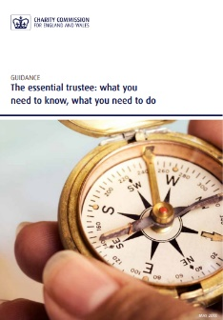
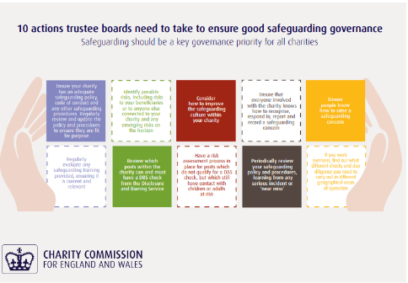 |  |  | 10 safeguarding actions for charity trustees infographic.pdf

Users and Hirers of Methodist premises

Church Councils must ensure that those who use their premises under license (or who hire the premises for regular or occasional use) are given a copy of the local church safeguarding policy and declare their willingness to comply with the safeguarding policy of the Methodist Church or comparable equivalent guidelines and procedures (e.g. Scouting and Guiding national safeguarding policy).

Depending on whether the arrangement with a third party is a one-off hire, regular part-time use under a licence or exclusive use under a lease, the requirements under charity law, Methodist law, policy and best practice are very different.

NB The safeguarding clause in the standard licence and template booking form replaces the need to complete Form E

Please follow the link below for more information:

TMCP Letting Property and Third-Party Use

Key documents
Licence flow chart | Tool to help ascertain what sort of arrangement being dealt with and how this is treated under charity law and Methodist law, policy and best practice
Licence Guidance - When to use the Standard Licence |  | Guidance exploring the differences between a lease and a licence
external users SG policy declaration agreement_july_2023.pdf (methodist.org.uk) |  | Confirmation of safeguarding policy arrangement declarations

Key holding
Remember that the Methodist Church is not obliged to give anyone access to church premises unless this is required as part of their role or for regular hire of premises.

Before the keys can be issued the key holder is asked to sign the declaration and acknowledge the conditions of issue – see Key Holder Declaration - Form D (methodist.org.uk)

It is good practice that the church property secretary audit on a regular basis those who holds keys and review whether this is still required.
Methodist policy guidance
Policies and guidance (methodist.org.uk) –
Here you will find the most current versions of:
- Safeguarding Policy, Procedures and Guidance for the Methodist Church

- Safer Recruitment Policy, Procedures and Guidance

- Domestic Abuse policy and procedure

- Safeguarding Risk Assessment Policy and Procedures

- Model Key Points for External User Groups of Premises

- Anti-Bullying policy – also at Appendix 1 of the main policy

- Procedures for safer working practice when managing children's activities – also at Appendix 2 of the main policy

- Procedures for the management of safeguarding information – also at Appendix 4 of the main policy
- Responding to character reference requests – also at Appendix 5b of the main policy

- Model Church Safeguarding Policy – also at Appendix 6a of the main policy

- Model Circuit Safeguarding Policy – also at Appendix 6b of the main policy

- Model District Safeguarding Policy – also at Appendix 6c of the main policy

- Role Descriptor for church safeguarding officer – also at Appendix 7a of the main policy

- Role Descriptor for Circuit Safeguarding Officer – also at Appendix 7b of the main policy
- Safeguarding Training Attendance – also at Appendix 9 of the main policy

- External Users' safeguarding policy declaration agreement – also at Appendix 10 of the main policy

- Safeguarding Guidance for Local Ecumenical Partnerships (LEPs)

Policies and guidance (methodist.org.uk)

