Record Keeping

Theme 8 from the Past Cases Review states:

Recording: Practice has improved but record keeping is still not consistent enough

- 2566 responses relating to 1885 individual situations were received.

- Written records relating to the reported safeguarding concerns had been kept in only 57% of cases.

In the church safeguarding records are needed to provide:

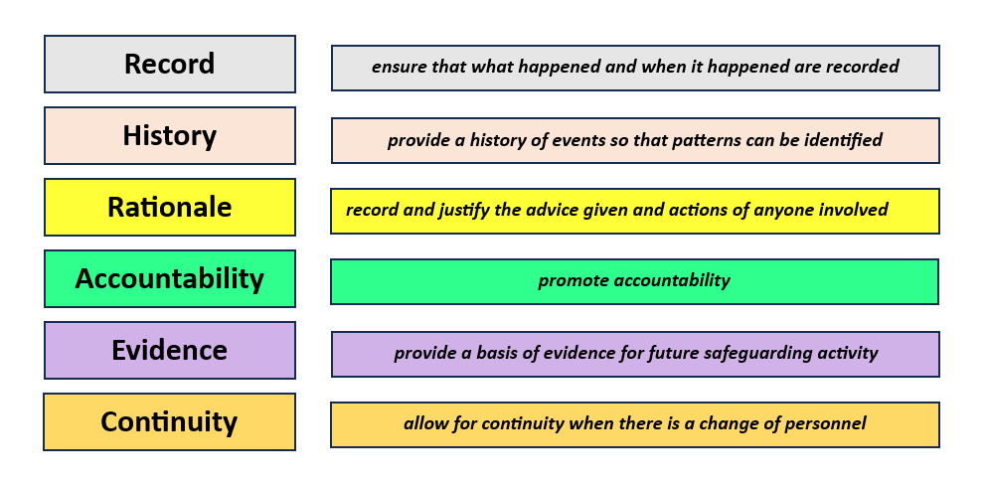

A good safeguarding record should be:

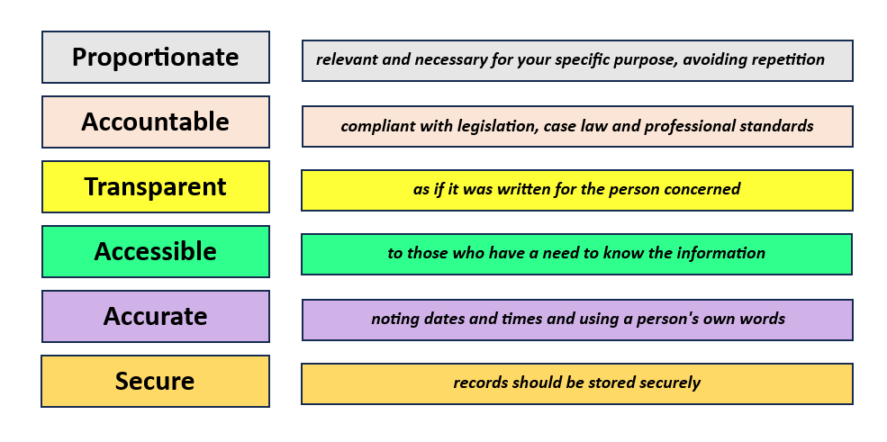

Recording a safeguarding concern

- Many people are concerned about having a specific form onto which they can record their concerns, and examples of such are available.

Connexional | church-sg-reporting-form-feb-2022.docx (live.com)
Local | Local Church Incident Recording Template | P5
Local | Local Church Safeguarding Notes Template | P6

- However, the significant action is ensuring you report the concern to someone. From there you can agree who puts the conversation into writing.

- Remember, a report can be a handwritten note that that is scanned and shared with someone else or may be contained within an email.

Remember SHARE

- Seek consent to share information

- Have regard to the law, rules and regulations

- Always act in the individuals’ best interests

- Record all discussions and activities

- Ensure individuals confidentiality is respected

Sharing the right information, at the right time, with the right people, is fundamental to good practice in keeping people safe but has been highlighted as a difficult area of practice for a number of organisations.

Retention and Archiving of Records
- Standing order 015 provides the authority to preserve the records of the church.

- For further information see Retention Schedules for Methodist Records

Retention schedule for safeguarding records p8

Technology

- Remember when disposing of or passing on computers to delete all sensitive information.

- All sensitive information should be stored on encrypted computers or data storage devices or should be password protected.

- Treat email, text or messages on other social media platforms with the same level of care and security as written correspondence.

- When getting rid of paperwork, shred all documents containing personal or sensitive information.

Privacy Notices

- Privacy notices are central to effective data protection practice within safeguarding, and they should be supplied using standard documents for specific activities including reporting a safeguarding concern.

- Standard documents can be found on the Methodist Church website and should be used on all occasions as the basis for information provided to individuals. This is to ensure that all information required by GDPR is supplied.

For further information see

This is the privacy notice for the Methodist Church in Great Britain which informs people about how the Church looks after personal data, about privacy rights and how the law protects it. |  |  | Privacy notice (methodist.org.uk)
Safeguarding Training Participants Privacy Notice | Safeguarding Training Participants Privacy Notice (methodist.org.uk)
Safeguarding DBS Verifier Privacy Notice | Safeguarding DBS Verifier Privacy Notice (methodist.org.uk)
Personal Data Processing Statements for anyone agreeing to act as a member of a Monitoring and Support group or anyone subject engaging with the Group because a concern has been raised about them |  |  | Monitoring and Support Groups (methodist.org.uk)
Privacy notice for anyone reporting a safeguarding concern and one for anyone who is the subject of a safeguarding concern. |  |  | Safeguarding Concerns (methodist.org.uk)
With Integrity and Skill |  | Confidentiality (methodist.org.uk)
Section 12 of the above document: Guidelines for Good Practice in Confidentiality and Pastoral Care |  | Guidelines for Good Practice in Confidentiality and Pastoral Care (methodist.org.uk)
Information sharing advice for safeguarding practitioners |  | Information sharing advice for safeguarding practitioners - GOV.UK (www.gov.uk)

Church Incident Recording Template
Church: |  | Circuit: |  | Date of occurrence:
Nature of occurrence in brief: E.g. accident, theft, assault, disclosure etc |  |  | Name of person reporting:
 |  |  | Signature:
 |  |  | Role of person reporting:
Name(s) of those involved/ witnessed:  1)  2)  3) |  | Any further action taken? e.g. first aid, contacted parent/carer, referral to other agency
Information shared with: please indicate all contacted  ☐ Minister  ☐ Church Safeguarding Officer  ☐ Circuit Safeguarding Officer | ☐ District  Safeguarding Officer  ☐ Other (please state) |  | Date information shared: |  | Were formal Church Safeguarding Notes commenced?  ☐ Yes  ☐ No
Further Information:

Church Safeguarding Notes Template
Church: | Circuit: | Date of occurrence:
Name of person reporting: | Role of person reporting: | Signature:

 | Name | Address | Age/DOB | Contact Number
Victim

Alleged Perpetrator
Other

Is the victim:  ☐ A child (aged 0-18 years)  ☐ A vulnerable adult  ☐ A survivor of church related abuse  ☐ A Methodist member  (please state role)  ☐ Other (please state) | Is the alleged perpetrator:  ☐ A child (aged 0-18 years)  ☐ A vulnerable adult  ☐ A survivor of church related abuse  ☐ A Methodist member  (please state role)  ☐ Other (please state) | Are you aware if the victim has any of the following vulnerabilities?  ☐ A physical disability/illness  ☐ A learning disability  ☐ A mental health illness  ☐ Alcohol/substance misuse  ☐ Risk of exploitation  ☐ Other (please state)  Or  ☐ No apparent vulnerability | Are you aware if the perpetrator has any of the following vulnerabilities?  ☐ A physical disability/illness  ☐ A learning disability  ☐ A mental health illness  ☐ Alcohol/substance misuse  ☐ Risk of exploitation  ☐ Other (please state)  Or  ☐ No apparent vulnerability

Nature of Abuse:  ☐ Physical Abuse  ☐ Emotional/Psychological (incl Domestic Abuse and Violence)  ☐ Neglect  ☐ Self-Neglect  ☐ Child Sexual Exploitation  ☐ Child Sexual Abuse current) | ☐ Child Sexual Abuse (non-current)  ☐ Financial  ☐ Discriminatory  ☐ Organisational  ☐ Spiritual  ☐ Online  ☐ Other (please state) | Information shared with: please indicate all contacted  ☐ Minister  ☐ Church Safeguarding Officer  ☐ Circuit Safeguarding Officer  ☐ District Safeguarding Officer  ☐ Other (please state)
When record keeping consider: who, what, where, when, actions taken
Date and Time | Notes relating to issue | Author  Role  Date

Retention schedule for safeguarding records
Basic record description | Retention Policy | Final Action
Clear Disclosure and Barring Service (DBS) certificate | Retain for 6 months from the recruitment decision | Destroy
Risk Assessment recommendations and a management plan in the event of an unclear or blemished DBS disclosure | Retain for 75 years after appointment / employment ceases / confirmation of blemished DBS details | Destroy
Records of other safeguarding adult or child protection concerns either within the church, church related activity, or within a family by an individual where the church was the reporting body or involved in care or monitoring plans that is any sex offender risk assessments and monitoring agreements  see Standing Order 010 | Retain for 75 years after the conclusion of the matter | Destroy
Records of any children’s activities, Sunday School/Junior Church/youth club registers and related general safety risk assessments.  Any communication from parents or other parties in relation to the above | Retain for 75 years after the conclusion of the matter | Destroy
Personnel records of individuals with contact with children and vulnerable adults including all documentation concerning any allegations and investigations regardless of the findings | Retain for 75 years after the conclusion of the matter
Records of complaints made through the Discrimination and Abuse Response Service | Retain for 6 years after the conclusion of the complaint

SHARE: consent, confidentiality and information sharing in mental healthcare and suicide prevention - GOV.UK (www.gov.uk) 2021

