Safeguarding, Activity and Risk Assessments
Although risk can never be completely mitigated, it is an everyday part of church activity and managing it effectively is essential:

- in order to help identify potential risk before it occurs

- in order to enable preventative measures to be put in place

- in order to provide a safer space for workers, volunteers and service users

- because it is a legal requirement for Church Councils/Circuit Meeting as charity trustee bodies

Charities and risk management (CC26) - GOV.UK (www.gov.uk)

- because it is often a requirement of insurance policies

Public liability and employer’s liability | Resource Centre
“If you take out public and/or employer’s liability insurance, your claim may be invalid if you have not done a risk assessment. A risk assessment ensures that you have thought about all the possible dangers and hazards beforehand and done as much as you can to prevent them.”

However, remember that risk assessments are also required across a number of other areas, including health and safety, fire prevention, food safety or first aid and although these are not the sole responsibility of the Safeguarding Officer there is a role in supporting completion of other such assessments.
But I can’t do risk assessments!!!
Can’t you? Because you do them every single day without really thinking about it.
For example:
Before you leave the house you check the weather outside so you know if you may need your coat, or an umbrella or your sunhat. You are assessing the risk of getting cold, or wet, or sunburned!!
You want to cross a busy road but you know it’s not a good idea to step out into the traffic as you may get hit. You may have a look up and down the road and decide that if you wait a few more seconds there will be a suitable break in the traffic to allow you to cross safely. Or you may think it is so busy that it would be best to walk a little further along the road until you come to pelican lights or a zebra crossing. This is a risk assessment; giving consideration to what harm could befall you and taking action to mitigate this.

Five steps to risk assessment
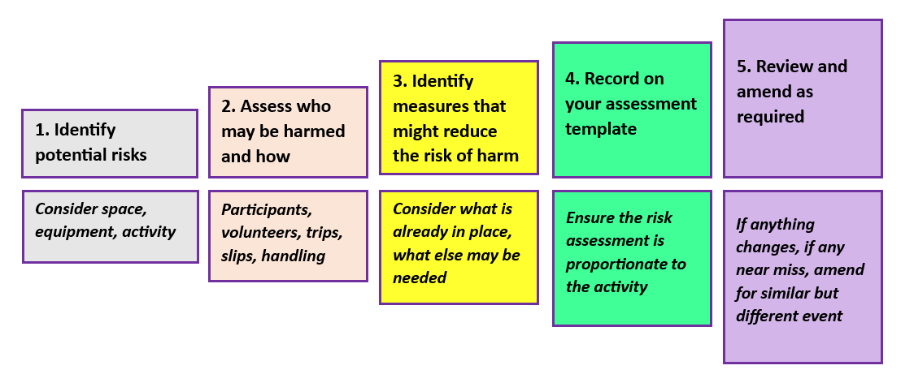

- Think about the context of your assessment, who may be harmed and what you can do to reduce the likelihood of this harm happening.

- Remember that often you are only writing down things you do almost unconsciously e.g. wiping up spills on the fall so someone does not slip, ensuring stair handrails are not loose

- Remember also that risk assessments should be revisited and updated regularly.

- Activity risk assessments should be undertaken before any activity takes place, be approved by the event leader/minister and retained securely in case they need to be seen at a later date (e.g. as a result of an accident taking place).

- Where a group is participating in a specialised activity, such as adventure activities, advice should be sought from the relevant licensing authority/organisation

e.g. The Adventure Activities Licensing Authority - AALA - HSE

- Remember, although we may not always get everything right, a risk assessment evidences that we are aware of risk and thinking about it.

- And they should be proportionate and relevant: you don’t need to write War and Peace or try to cover every possibility.

Other local risk assessment resources

Safeguarding Risk Assessment Checklist  For Leaders of Methodist Church Activities on Methodist Premises | P4
Local Model Activity Risk Assessment | P6
Blank Risk Assessment: Group  Taken from: “A Guide to Planning and Organising Events for Children and Young People” Methodist Children and Youth | P7

Other Useful guidance - Connexional Risk Assessments/Inspections

Building Risk Assessment Template |  | Policies and guidance (methodist.org.uk)
A-Z listing of regular inspections of Methodist property |  | Regular Inspections (methodist.org.uk)
Handy 12-month risk calendar with key dates through the year to help you look after and protect your church and those who use it |  | Risk Calendar | Risk Management (methodistinsurance.co.uk)
Lone Working | Lone Working Risk Assessment and Guidelines. (methodist.org.uk)
Methodist church event checklist |  | Church Events | Risk Management Articles | Methodist Insurance
Keeping people safe when planning larger events - Health and safety toolkit |  | Health and safety toolkit | Events | Methodist Insurance
Health and Safety – self-assessment for churches |  | Self Assessments | Risk Management Articles | Methodist Insurance
Introduction to fire safety |  | Introduction to fire safety - HSE
Fire safety for Methodist churches |  | Fire Safety | Risk Management Articles | Methodist Insurance
Methodist Insurance Risk Advice Line | 0345 600 7531 |  | risk.advice@micmail.com

Safeguarding Risk Assessment Checklist

For Leaders of Methodist Church Activities on Methodist Premises

Points to be considered  Please remember that this list is not exhaustive | YES | NO | N/A
Trustworthy Leaders, able to safeguard themselves and others

Are all leaders recruited in accordance with the Methodist Church Safer Recruitment Policy, Procedures and Guidance? (including consideration of required DBS, safeguarding training, references/ recommendations etc.?)

Are they supervised and regularly supported?

If necessary, are the good practice guidelines of Procedures for Safer Working Practice When Managing Children's Activities followed?

Have key holders signed a Key Holder Declaration Form? (regarding care of premises; not sharing keys etc)

Enough skilled leaders to manage people safely

Are ratios of leaders to participants acceptable?

Is there a procedure for cancellation of the event if the ratio cannot be achieved?

Are all other training needs of leaders identified and met?

Safe use of digital media

If using digital media in any way, is the appropriate Methodist guidance (connexional and/or local) being followed? (including social media, websites, recording for online use)

Records and Privacy arrangements

Are required records forms maintained and kept in accordance with data protection guidelines? (e.g. consent forms, registers, emergency contacts/ privacy notices)

Safe in an in an emergency

Are safety arrangements clear to leaders?
(Fire procedures, Accidents, First Aid, Phone access etc.)

Physically Safe

Is the space and equipment you are using appropriate and safe for the purpose of the event/activity? (e.g. any obstacles, moving furniture, room capacity, etc.)

If arranging transport/lifts or escorting people are the required checks done and records kept?

Do leaders arrive before/leave after group members (especially for children or vulnerable adults)

Dealing with safeguarding concerns about participants or leaders

Does the leader know what to do, who to contact for help, how to report to Church/ Circuit/District Safeguarding Officer?

Dealing with other complaints

Do leaders know the procedure for reporting situations within the church, including unacceptable conduct?

Other aspects to consider which may need to be addressed via other means e.g.

Are any Leaders likely to be working alone in the premises?

Is there access to First Aid material and an accident book?

Has an annual church risk assessment been undertaken?

Local Model Activity Risk Assessment
Church/Venue |  | Group/Event
Date(s)/frequency |  | Date of assessment:
Leader name |  | Email: |  |  | Tel:

Activity | Possible risk | Actions already being taken | Other actions to be taken to reduce risk | Whose responsibility? | Date action completed

Blank Risk Assessment: Group
Taken from: “A Guide to Planning and Organising Events for Children and Young People” Methodist Children and Youth
organising-events-guidance-pack-large.pdf (methodist.org.uk)

Event: |  | Group Leader:
Location: |  | Phone:
Date: |  | Email:

Activity | Possible risk | Prevention | Action to be taken  to reduce risk | Responsibility
Completed by:

Signed:

Date:

Policies and guidance (methodist.org.uk)
This means a conversation is had about how the volunteer feels, what they do, whether this reflects the role description and is carried out annually as a minimum.
Policies and guidance (methodist.org.uk)
See Methodist policy above: Section 4 - Responding well to Safeguarding Incidents

