Safeguarding Training
- The Methodist Church offers safeguarding training at both Foundation and Advanced levels.

- For clarity as to which roles require which level of safeguarding training, please see p5 (foundation) and p7 (advanced)

- Everyone must complete the Foundation Module at least once, but for those whose role requires them to complete the Advanced Module subsequent refreshers, currently every 4 years, need only be undertaken at Advanced level until a role change indicates this is no longer necessary.

- A new office holder must successfully complete the required safeguarding module(s) within six months of taking up a post and if not, may be suspended until the training has been completed.

- The same risk of suspension applies for those who fail to complete refresher training in a timely manner, and anyone who feels they may not be able to complete as required will need to discuss their situation with the Circuit SGO in respect of Foundation Module and the DSO in respect of Advanced Module at the earliest opportunity.

- People who have received safeguarding training in other roles (e.g. as a teacher or police officer) still need to attend because the training is specific to the church context. Their attendance is also valuable because of the expertise they can share with other attendees.

Foundation sessions:
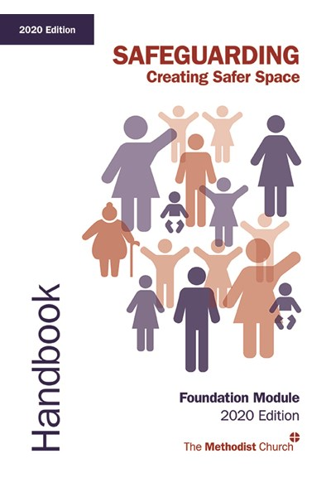
- The DSG requires that each Circuit offer the Foundation Module at least once every six months, although this can be done in collaboration with other Circuits.
- Sessions are booked and planned by trainers within the Circuits. However, where there is capacity for those from other circuits to attend the dates and booking information will be included in the weekly newsletters of both Districts.

- For online Foundation sessions coordinated by the DSO, these can be found and booked from the Bolton & Rochdale website events pages

- On completion of a session facilitators are requested to send a copy of the attendance list, including role of the attendee, for maintenance of the district database to:

DSO at mands@dso.methodist.org.uk and pa@mandsmethodists.org.uk
Advanced sessions:
- Are a District responsibility and are booked and managed by the admin team from B&R and facilitated by the DSO and volunteers.

Face-to-face Training:

- Unit 1a: Preparing the Ground Booklet - an hour of self-study

- Core learning session (Units 1b-5) - minimum of 4 hours taught

Online Training:

- E-learning (units 1-5a) - approximately 4 to 7 hours which can be completed in smaller sections. Alongside the e-learning, participants complete a Workbook which they then take to the Gathered session.

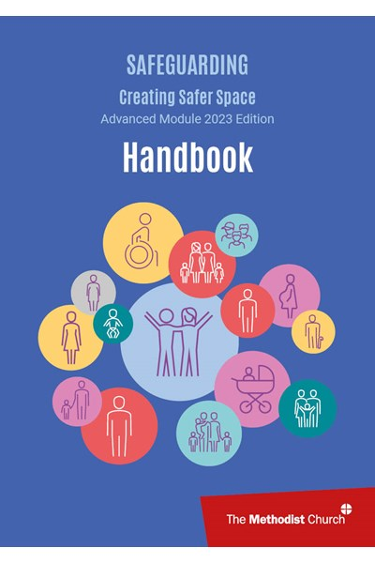

- Gathered Session (Unit 5b) – a 2 hour facilitated session to consolidate learning from Advanced Module (online) e-learning. This may be delivered via zoom or face to face.

N.B. the e-learning MUST be completed before attending a Gathered Session

How to book sessions:

- Both Modules are currently available both online and face to face but facilitation of both is dependent upon our having sufficient numbers of volunteers to deliver the required sessions.

- However, circuits generally publicise local sessions in advance of sharing more widely

- A signed consent form is not required as attendance at the session implies implicit consent, although the relevant privacy notices should be made available to participants

Booking Advanced Module sessions:
- All sessions can be found and booked from the Bolton & Rochdale website events pages
3
District Events | Bolton and Rochdale Methodist District (barmd.org.uk)

- There are a number of ways that the Advanced module can be completed to meet a range of different requirements and learning styles so please ensure you make the correct selection when you book (see following image)

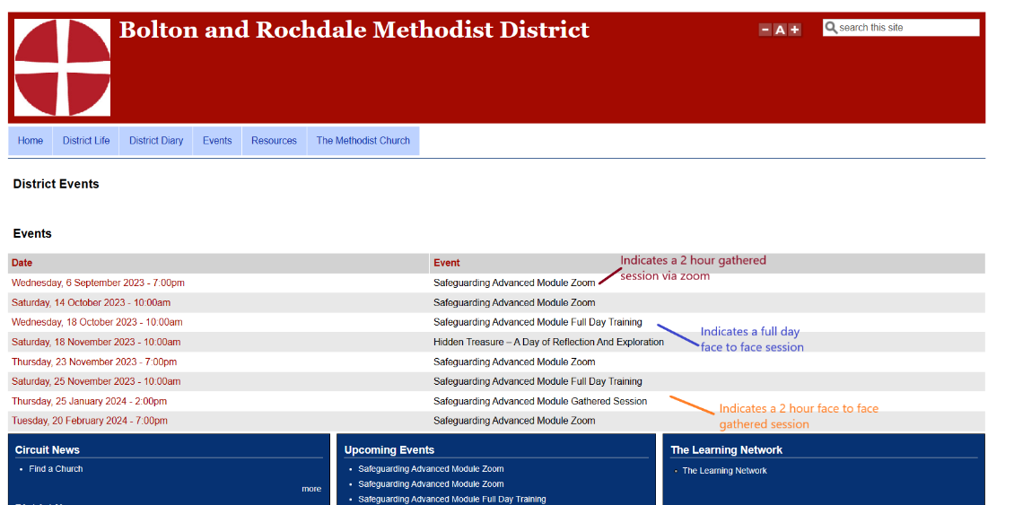

What happens when I book?
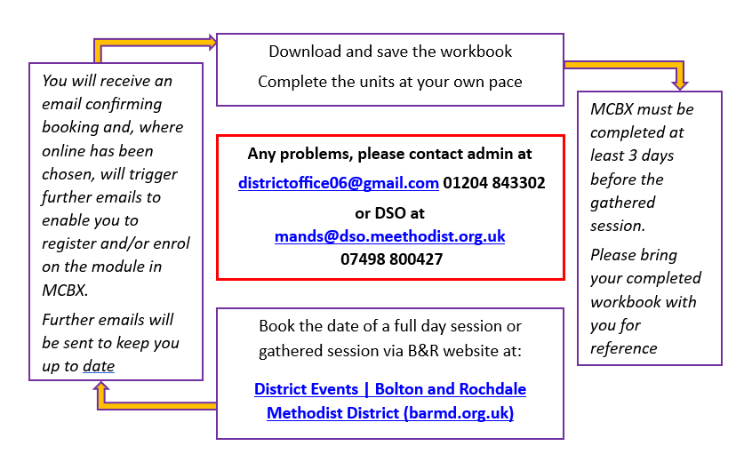

Train the Trainer sessions
- Train the Trainer for both modules are run generally once a year, facilitated by a member of the Learning Network together with one of the DSOs from the region.

- If you are aware of anyone who may be able to support delivery of either of the safguarding modules and wishes to attend a session to see if it is for them, please contact the DSO and share the individual’s details so that they can be kept up to date.

- In order to attend the training a letter of recommendation is needed from the superintendent minister (or similar if this is not currently possible).

- During the session we will explore the Module; the resources needed to deliver the Module; how to deliver and facilitate the session well; what happens following the training and the ongoing support available.

- As a minimum we will meet at least once a year for support and updating and more often where the module has undergone its four yearly update. Other relevant information will be shared via email, as necessary.

Foundation Module (2020 edition) Safeguarding Training Attendance

Core List – Required Attendance

- Presbyters with an active preaching or pastoral ministry

- Deacons with an active preaching or pastoral ministry

- Pre-ordination students and probationers

- Lay employees and volunteer workers with pastoral responsibility

- Pastoral visitors

- Anyone working with children in the name of the church

- Anyone working in activities targeted at adults who are vulnerable (e.g. luncheon club for the housebound)

- Circuit stewards

- Church stewards

- Local preachers local preachers should enrol and complete the Foundation Module at the earliest opportunity after receiving a Note to Preach. Both Foundation and Advanced modules must be completed by the end of the second year of training and before their second interview on trial, whichever occurs first

- Worship leaders worship leaders should enrol and complete the Foundation Module at the earliest opportunity after commencing training. Both Foundation and Advanced modules must be complete by the end of the second year of training and before their appointment by the Church Council, whichever occurs first

- Church and circuit safeguarding representatives

- Choir/music group/drama leaders – where there are children or vulnerable adults in the group.

- District staff especially policy committee members, complaints and discipline, mediators

- Core teaching staff at Methodist Church Training Institutions

- Connexional staff with direct safeguarding links e.g. children and youth workers

- Monitoring and Support group members (for Safeguarding Contracts)

- Young Leaders (ages 16-18)

- Members of the Safeguarding Committee

Warmly invited but not mandatory

- Leaders of other groups or organisations that regularly hire or use Methodist premises for work with children and vulnerable adults but do not have access to safeguarding training elsewhere and do not have their own safeguarding policy

- Remaining Choir/music group/drama leaders

- Any other group leaders within the church, who may have adults who are vulnerable within their group.

- Property stewards and other key holders

- Caretakers

- Church/circuit meeting secretaries

- Church/circuit/district administrators

- Remaining District and connexional staff

- Remaining teaching staff at Methodist Church Training Institutions

Renewing Training

The requirement to renew training every four years will only apply to the highest level of safeguarding training undertaken by any individual. If the highest level of training is Foundation Module, then a repeat of this module will be necessary after four years.

The 2016 Conference decided that the frequency of undertaking Creating Safer Space training should change from five to four years from September 2017 in order to make sure that training content can keep pace with changes in legislation and safeguarding practices.

Recognition of Church of England Training

The Methodist Church recognises the Church of England Foundation Module (previously called C1) as equivalent and qualifying training to the Foundation Module. Therefore, those who have undertaken that Church of England course will have satisfied attendance requirements listed above in the Methodist Church.

Agreed by Methodist Council and Safeguarding Committee 2019

Advanced Module Safeguarding Training Attendance

Core List – Required Attendance

- Safeguarding Officer – District

- Safeguarding Officer – Circuit

- Safeguarding Officer – Church

- Members of the District Safeguarding Group

- Members of the District Policy Committee

- All presbyters or deacons with an active preaching or pastoral ministry (including supernumerary ministers)

- Those who are in paid employment or a voluntary role which includes leadership within the Methodist Church, involving direct work with children, young people or vulnerable adults those with responsibility for supervision (either training or trained and accredited under the Methodist Church Reflective Supervision Policy 2021-26)

- Lay persons who are appointed to exercise pastoral leadership within a local church

- Local preachers local preachers should enrol and complete the Advanced Module at the earliest opportunity after receiving a Note to Preach and completing the Foundation Module. Both modules must be completed by the end of the second year of training and before their second interview on trial, whichever occurs first

- Worship leaders worship leaders should enrol and complete the Advanced Module at the earliest opportunity after commencing training and completing the Foundation Module. Both modules must be complete by the end of the second year of training and before their appointment by the Church Council, whichever occurs first

- Those who deliver the Foundation Module

- Evangelism/mission enablers

- Circuit stewards

- Members of the Connexional Complaint Panels, Discipline Committees, Pastoral and Appeals Committees

- Those in recognised roles involving pioneering, fresh expressions or evangelism

- Mentors for the Youth Participation Scheme

- Members of the Safeguarding Committee

Warmly invited but not mandatory

- Supernumerary ministers apart from those who have an active preaching or pastoral ministry.

- Specific groups not required to attend the whole module should attend training covering specific sections e.g. volunteers in direct work with children, young people or vulnerable adults.

Recognition of Church of England Training

The Methodist Church recognises the Church of England Leadership Module (previously called C2) as equivalent and qualifying training to the Advanced Module. Therefore, those who have undertaken that Church of England course will have satisfied attendance requirements listed above in the Methodist Church.

Renewing Training

The requirement to renew training every four years will only apply to the highest level of safeguarding training undertaken by an individual. Where the Foundation and Advanced Modules are required, following attendance at both courses, only a repeat of the Advanced Module will be necessary in future years.

Agreed by Methodist Council and Safeguarding Committee 2019

conf-2016-30-Safeguarding.pdf (methodist.org.uk)

