Shared duty
Although we acknowledge that safeguarding in our churches and church communities is everyone’s responsibility there are those within the districts, circuits and churches who hold key roles, see below.
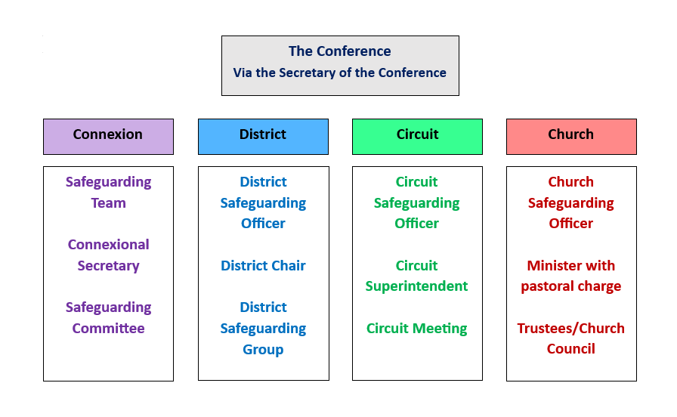

Summary of key safeguarding responsibilities for those at circuit and church level include:
Circuit Superintendent  Full role description p3 | > offers support and oversight in implementing good safeguarding practice across the circuit.  > offers supervisory oversight to the circuit SGO.  > supports the circuit SGO in completing and feeding back the outcome of the annual safeguarding audit.  > supports the DSO in managing any safeguarding assessments/ contracts within the circuit.

Minister with pastoral charge  Full role description p5 | > supports the Church SGO, office holders and Church Council in implementing good safeguarding practice in their churches.  > supports the Church SGO in completing and reporting the annual safeguarding audit.  > passes over details of any safeguarding issues to the new minister when leaving the Circuit.

Circuit Safeguarding Officer  Full role description p6 | > although the circuit meeting holds the responsibility for safeguarding, these are delegated to the Circuit SGO.  > together with the Circuit Superintendent, provides support and oversight for local churches and ministers in implementing good safeguarding practice across the circuit.  > is the first point of contact for all those within the circuit for all safeguarding concerns.  > meets at least annually with church safeguarding officers to offer support and guidance.  > together with the Circuit Superintendent, supports completion of the annual circuit safeguarding audit and reports any deficits/ action plan to the Circuit Meeting.

Church Safeguarding Officer  Full role description p8 | > supports and advises all members of the church in understanding their safeguarding responsibilities.  > works in partnership with the lettings officer, stewards and user groups to promote good safeguarding practice on church premises.  > ensures that the church safeguarding policy is reviewed and updated annually.  > completes the annual church safeguarding audit and share the results with the circuit safeguarding officer.

However, safeguarding is a whole church responsibility and therefore everyone in our church communities has a collective responsibility to protect the most vulnerable and to uphold the rights of the least powerful as an expression of the love of God.

Other useful information:

Safeguarding Policy, Procedures and Guidance | Policies and guidance (methodist.org.uk)
Safer Recruitment Policy, Procedures and Guidance | Policies and guidance (methodist.org.uk)
The Covenant Relationship between the Church and its Ministers: Commitments and Expectations | Conference 2022 Agenda Volume 2 (methodist.org.uk)

Role responsibility for safeguarding: Circuit Superintendent

Key Relationships | Chair of District, District Safeguarding Officer (DSO), Circuit Safeguarding Officer (SGO)
Role Purpose | Together with the Circuit Safeguarding Officer, the Circuit Superintendent provides support and oversight for local churches and ministers in implementing safeguarding according to good practice and safeguarding procedures.
Role Responsibilities | To ensure that all churches have appropriate and up-to-date safeguarding policies in place.  To support those in pastoral charge in fulfilling their responsibility in implementation of safeguarding policy and practice.  To ensure the provision of pastoral support for those involved in issues of abuse and in the management of those who present a safeguarding risk.  To ensure that training opportunities are in place for all workers with children, vulnerable adults, for staff of the circuit and for members of the local churches in the circuit, in accordance with Methodist policy.  To ensure DBS checks and training requirements for ministers in the circuit are up to date.  To ensure that safeguarding is a regular agenda item at Circuit Meetings.  To ensure that safeguarding is a regular part of the conversation at Circuit staff meetings.  To ensure that the Circuit Meeting appoints a circuit safeguarding officer and reviews the safeguarding policy annually.  To support the Circuit SGO in their work, providing access to resources to enable them to fulfil their functions.  To provide supervisory oversight to the Circuit SGO, or nominate a substitute, and ensure records are kept of all such supervisory meetings.  To support the Circuit SGO with the annual circuit safeguarding review and ensure the Circuit Meeting is aware of any deficits and action plans.  To ensure that all roles, whether paid or voluntary, are recruited to safely and in accordance with Methodist policy  To ensure that all safeguarding allegations/concerns/incidents are responded to immediately, managed as per Safeguarding policy and the requisite advice sought.  Suspension of a minister, probationer, student or lay office holder under SO 013 if identified as the responsible officer within the standing order  With the guidance and support of the DSO to assist in the safeguarding contract process, including chairing of Monitoring and Support Groups and ensuring appropriate pastoral care as necessary.  To advise Safeguarding officers of any complaint or issue relating to the potential abuse of children or adults who may be vulnerable.  To be aware of the provisions of SO 692 should a person who is deemed to present a safeguarding risk decide to worship in a church other than where their contract is.
Requirements | This role requires an enhanced DBS, both child and adult workforce, with barred list check.  Completion of Advanced Safeguarding Module.

For further information see:
superintendents-handbook-update-jan2023.pdf (methodist.org.uk)

Role responsibility for safeguarding: Minister with pastoral charge

Key Relationships | Chair of District  District Policy Committee/  District Council  District Safeguarding Officer | Circuit Superintendent  Circuit Safeguarding Officer  Church Safeguarding Officer
Role Responsibilities as minister in pastoral charge | To support the Church Safeguarding Officer, office holders and Church Council in good safeguarding practice in the churches.  Together with the Church SGO, to ensure safeguarding practice and policy is audited annually, including of DBS checks and safeguarding training.  To ensure that all those with responsibility for recruitment, whether paid or voluntary, are aware of the requirement to follow safer recruitment procedures.  Together with the Superintendent, to ensure that all safeguarding allegations/concerns/incidents are responded to immediately, managed as per Safeguarding policy and the requisite advice sought.  With the guidance and support of the DSO to assist in the safeguarding contract process, including chairing of Monitoring and Support Groups and ensuring appropriate pastoral care as necessary.  To notify the minister in the new location if the subject of a current safeguarding contract is moving to worship elsewhere.  To pass over details of any safeguarding contract to the new minister (as per SO 692) when leaving the Circuit. If there are no safeguarding contracts, this should be confirmed.
Requirements | This role requires an enhanced DBS, both child and adult workforce, with barred list check.  Completion of Advanced Safeguarding Module.

Role responsibility for safeguarding: Circuit Safeguarding Officer (SGO) - voluntary
Responsible to | Circuit Meeting
Key Relationships | Circuit Meeting, Circuit Superintendent, Church Safeguarding Officers, District Safeguarding Officer
Supervisory Oversight | Will be provided by the Circuit Superintendent, or a nominated substitute and records maintained of all meetings.
Role Purpose | Together with the Circuit Superintendent, the Circuit Safeguarding Officer provides support and oversight for local churches and ministers in implementing safeguarding according to good practice and safeguarding procedures.  Although the circuit meeting holds the following responsibilities, these are delegated to the Circuit Safeguarding Officer.  For further information please see the Circuit Safeguarding Policy
Role Description | To support and advise the circuit superintendent regarding all aspects of safeguarding, including record keeping and sharing of concerns.  To be the first point of contact for ministers, staff, volunteers, church safeguarding officers and trainers within the circuit for all safeguarding concerns.  To be the conduit for the sharing of information and updates relating to safeguarding across the district.  To meet at least annually with church safeguarding officers to offer support and guidance.  To support attendance at and maintain records of all safeguarding training undertaken within the circuit.  To advise on and support safer recruitment practices throughout the circuit.  To support application for and maintain records of all Disclosure and Barring Service (DBS) checks undertaken for circuit roles, and to support church safeguarding officers to ensure that all necessary DBSs are completed and recorded.  To ensure that safeguarding is a standing item on the circuit meeting agenda and that a report presented which includes areas of concern.  Together with the circuit superintendent, to support completion of the annual circuit safeguarding review and ensure the circuit meeting is aware of any deficits and action plan. This review includes audit of receipt and review of church risk assessments, safeguarding policies, DBS and training schedules for each church in the circuit and sharing the results with the DSO and circuit meeting.  Together with the minister in pastoral charge, to support the DSO with the setting up and management of Monitoring and Support Groups for those subject to safeguarding contracts.
Required skills and experience | Experience in using administrative systems, including word documents, spreadsheets and databases.  Organised and able to respond in a timely manner.  Awareness of confidentiality and GDPR issues within safeguarding.  Calm, sensitive, good relationships with others.  Trained to, or willing to train to, Advanced Safeguarding Module level.  Willingness to engage in regular updates and safeguarding training.
Requirements | This role requires an enhanced DBS, both child and adult workforces, without barred list check.

Role responsibility for safeguarding: for Church Safeguarding Officer (voluntary)
Responsible to | Church Council, through the minister with pastoral oversight.
Key Relationships | Church council, minister, circuit safeguarding officer, district safeguarding officer.
Supervisory Oversight | Will be provided by the minister with pastoral oversight, or a nominated substitute and records maintained of all meetings.
Role Purpose | To support and advise all members of the church in understanding their safeguarding responsibilities.
Role Description | To ensure that the church safeguarding policy is reviewed and updated annually and available as a hard copy and/or electronically.  To ensure that safeguarding is a standing item on the church council meeting agenda and that a report is presented at least annually.  To ensure that all those with responsibility for recruitment, whether paid or voluntary, are aware of the requirement to follow safer recruitment procedures.  To ensure that the names of current safeguarding officers, national helplines and other suitable information are displayed on the church safeguarding noticeboard.  To ensure that all reported safeguarding issues are recorded appropriately, as per Methodist policy and procedures.  To identify those who are required to attend safeguarding training and maintain records of attendance.  To work with and support the Circuit Safeguarding Officer and Foundation Module trainers to ensure delivery of training.  To complete the annual church safeguarding audit and share the results with the circuit safeguarding officer.  To advise the circuit safeguarding officer and/or DSO of any issues with compliance with safeguarding training, policy or safer recruitment requirements.  To work in partnership with the lettings officer, stewards and user groups to promote good safeguarding practice on church premises.  This will include confirming in writing that hirers of church premises are aware of the church safeguarding policy or are using an appropriate policy of their own.
Required skills and experience | Some knowledge and experience of safeguarding and of working with children, young people or vulnerable adults would be helpful.  Good communication and administrative skills.  Trained to, or willing to train to, Advanced Safeguarding Module level.  Willingness to engage in regular updates and safeguarding training.
Requirements | This role requires an enhanced DBS, child and adult workforces, without barred list check.

